KICKOFF OF THE PARISH PHASE OF THE NATIONAL EUCHARISTIC REVIVAL

**SAMPLE BULLETIN/SOCIAL MEDIA ANNOUNCEMENT**

**NATIONAL EUCHARISTIC REVIVAL—PARISH PHASE**

The dioceses of the United States are currently engaged in a multi-year National Eucharistic Revival to renew the Church by enkindling in the faithful a living relationship with the Lord Jesus Christ in the Holy Eucharist. We are now approaching the parish phase of the Revival beginning on Sunday, June 11, 2023, the Solemnity of the Most Holy Body and Blood of Christ (Corpus Christi).

To commemorate the beginning of the parish phase of the National Eucharistic Revival, our parish will be offering a [please list your event--Eucharistic Procession/Eucharistic Exposition and Benediction/Eucharistic Holy Hour] on [date and time] at [location]. Please plan on joining us and pray for the fruitfulness of the Revival.

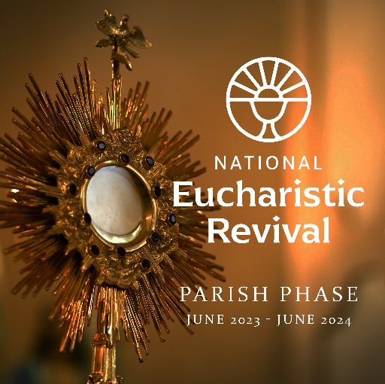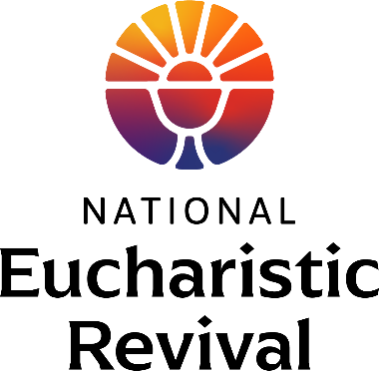Look for more opportunities to engage in the National Eucharistic Revival soon!