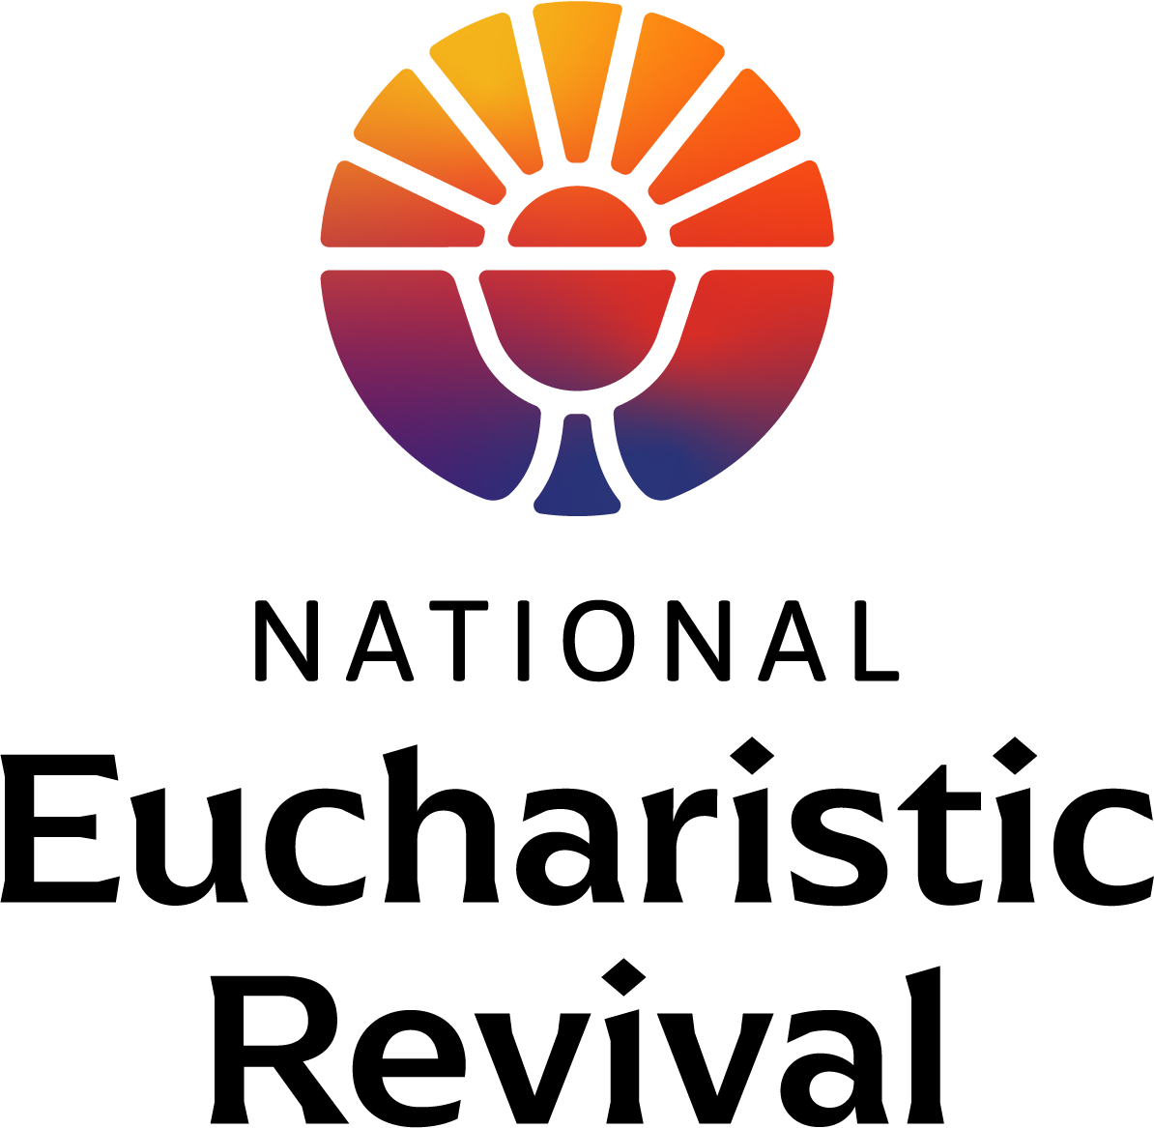

EVENING PRAYER II

DURING THE PERIOD OF

EUCHARISTIC EXPOSITION

AS PART OF THE PARISH OBSERVANCE OF THE

NATIONAL EUCHARISTIC REVIVAL

EXPOSITION

OF THE BLESSED SACRAMENT

*(If the Blessed Sacrament is not already exposed on the altar)*

STAND

**Procession of the Ministers**

*All stand while the ministers process to the sanctuary. Once there, the presiding minister goes to the tabernacle.*

KNEEL

**EXPOSITION HYMN**

*The presiding minister takes the Blessed Sacrament from the tabernacle and places it in the monstrance on the altar. All kneel. The Blessed Sacrament is then incensed while the Exposition Hymn is sung by the faithful.*

**SILENT ADORATION**

*Follow the Exposition Hymn, the faithful are encouraged to spend some time in quiet prayer before the Lord in the Blessed Sacrament. After a suitable amount of time, the Holy Hour continues with Evening Prayer.*

**

*Artwork by Sr. Jeanne Ambre, SS. C.M.*

EVENING PRAYER II

STAND

**Invitatory**

*All stand and make the Sign of the Cross.*

Presider: God, ✠ come to my assistance.

**All: Lord, make haste to help me.**

Presider: Glory to the Father, and to the Son,

and to the Holy Spirit:

**All: as it was in the beginning,**

**is now, and will be for ever. Amen. [Alleluia.]**

*The Alleluia is omitted during Lent.*

**Hymn**

*An appropriate hymn is sung. After the hymn, all are seated for the Psalmody.*

SIT

**Psalmody**

Presider:Christ the Lord is a priest for ever in the line of Melchizedek; he offered up bread and wine.

**Psalm 110:1-5, 7**

The Messiah, king and priest

*Christ’s reign will last until all his enemies are made subject to him* (I Corinthians 15:25).

*I—Left Side* ***II****—Right Side*

I The Lord’s revelation to my Master:

“Sit on my right:

your foes I will put beneath your feet.”

**II** The Lord will wield from Zion

your scepter of power:

rule in the midst of all your foes.

I A prince from the day of your birth

on the holy mountains

from the womb before the dawn I begot you.

**II** The Lord has sworn an oath he will not change.

“You are a priest for ever,

a priest like Melchizedek of old.”

I The Master standing at your right hand

will shatter kings in the day of his great wrath.

**II** He shall drink from the stream by the wayside

and therefore he shall lift up his head.

I Glory to the Father, and to the Son,

and to the Holy Spirit:

**II** As it was in the beginning, is now,

and will be forever. Amen.

**All: Christ the Lord is a priest for ever in the line of Melchizedek; he offered up bread and wine.**

Presider:I will take up the cup of salvation, and I will offer a sacrifice of praise.

**Psalm 116:10-19**

Thanksgiving in the Temple

*Through Christ let us offer God a continual sacrifice of praise* (Hebrews 13:15).

*I—Left Side* ***II****—Right Side*

I I trusted, even when I said:

“I am sorely afflicted,:

and when I said in my alarm:

“No man can be trusted.”

**II** How can I repay the Lord

for his goodness to me?

The cup of salvation I will raise;

I will call on the Lord’s name.

I My vows to the Lord I will fulfill

before all his people.

O precious in the eyes of the Lord

is the death of his faithful.

**II** Your servant, Lord, your servant am I;

You have loosened my bonds.

A thanksgiving sacrifice I make:

I will call on the Lord’s name.

I My vows to the Lord I will fulfill

before all his people,

in the courts of the house of the Lord,

in your midst, O Jerusalem.

**II** Glory to the Father, and to the Son,

and to the Holy Spirit:

I as it was in the beginning, is now,

and will be forever. Amen.

**All: I will take up the cup of salvation, and I will offer a sacrifice of praise.**

Presider:You are the way, the truth and the life of the world, O Lord.

**Revelation 19:1-7**

*The wedding of the Lamb*

*I—Left Side* ***II****—Right Side*

*The alleluia at the beginning and end of each verse is omitted during Lent.*

I [Alleluia.]

Salvation , glory, and power to our God:

His judgments are honest and true. [Alleluia.]

**II** [Alleluia.]

Sing praise to our God, all you his servants,

All who worship him reverently, great and small. [Alleluia.]

I [Alleluia.]

The Lord our all-powerful God is King;

Let us rejoice, sing praise, and give him glory. [Alleluia.]

**II** [Alleluia.]

The wedding feast of the Lamb has begun,

And his bride is prepared to welcome him. [Alleluia.]

I [Alleluia.]

Glory to the Father, and to the Son,

and to the Holy Spirit: [Alleluia.]

**II** [Alleluia.]

as it was in the beginning, is now,

and will be forever. Amen. [Alleluia.]

**All: You are the way, the truth and the life of the world, O Lord.**

**Reading**

**Homily**

*A priest or deacon may offer a brief homily following the reading. After the reading or homily silence may be observed.*

**Responsory**

*Outside of Lent, the following Responsory is used:*

Reader: He gave them bread from heaven, alleluia, alleluia.

**All: He gave them bread from heaven, alleluia, alleluia.**

Reader: We have eaten the bread of angels

**All: alleluia, alleluia.**

Reader: Glory to the Father, and to the Son, and to the Holy Spirit.

**All: He gave them bread from heaven, alleluia, alleluia.**

*During Lent, the following Responsory is used:*

Reader: We though many are one bread, one body: for we all share the one bread and the one cup.

**All: We though many are one bread, one body: for we all share the one bread and the one cup.**

Reader: You have made us live in peace in your house, O Lord;

**All: for we all share the one bread and one cup.**

Reader: Glory to the Father, and to the Son, and to the Holy Spirit.

**All: We though many are one bread, one body: for we all share the one bread and the one cup.**

STAND

**Canticle of Mary**

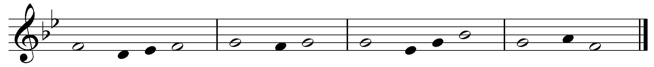

Cantor:How holy this feast in which Christ ***is*** our food;

his passion ***is*** recalled;

grace ***fills*** our hearts;

and we receive a pledge of the glory ***to*** come, (alleluia.)

*The Alleluia is omitted during Lent.*

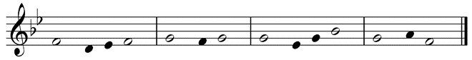

*All make the Sign of the Cross while singing:*

**All:** My soul ✠ proclaims the greatness ***of*** the Lord,

my spirit rejoices in God ***my*** Savior

for he has ***looked*** with favor

on his low***ly*** servant.

From this day all ***gen***erations

will call ***me*** blessed:

the Almighty has done great ***things*** for me

and holy is ***his*** Name.

He has mercy on ***those*** who fear him

in every gen***er***ation.

He has shown the strength ***of*** his arm,

he has scattered the proud in their ***con***ceit.

He has cast down the mighty ***from*** their thrones,

and has lifted up ***the*** lowly.

He has filled the hungry ***with*** good things,

and the rich he has sent a***way*** empty.

He has come to the help of his ***ser***vant Israel

for he has remembered his promise ***of*** mercy,

the promise he made ***to*** our fathers,

to Abraham and his children ***for*** ever.

Glory to the Father, and ***to*** the Son,

and to the Ho***ly*** Spirit:

as it was in the begin***ning*** is now,

and will be forever. ***A***men.

**All:** How holy this feast in which Christ ***is*** our food;

his passion ***is*** recalled;

grace ***fills*** our hearts;

and we receive a pledge of the glory ***to*** come, (alleluia.)

*The Alleluia is omitted during Lent.*

**INTERCESSIONS**

Presider: Christ invites all to the supper in which he gives his body and blood for the life of the world. Let us ask him:

**All: Christ, the bread from heaven,**

**grant us everlasting life.**

Reader: Christ, Son of the living God, you commanded that this thanksgiving meal be done in memory of you, enrich your Church through the faithful celebration of these mysteries.

**All: Christ, the bread from heaven,**

**grant us everlasting life.**

Reader: Christ, eternal priest of the Most High, you have commanded your priests to offer your sacraments, may they help them to exemplify in their lives the meaning of the sacred mysteries which they celebrate.

**All: Christ, the bread from heaven,**

**grant us everlasting life.**

Reader: Christ, bread from heaven, you form one body out of all who partake of the one bread, refresh all who believe in you with harmony and peace.

**All: Christ, the bread from heaven,**

**grant us everlasting life.**

Reader: Christ, through bread you offer the remedy for immortality and the pledge of future resurrection, restore health to the sick and living hope to sinners.

**All: Christ, the bread from heaven,**

**grant us everlasting life.**

Reader: Christ, our king who is to come, you commanded

that the mysteries which proclaim your death be celebrated until you return, grant that all who die in you may share in your resurrection.

**All: Christ, the bread from heaven,**

**grant us everlasting life.**

**THE LORD’S PRAYER**

BENEDICTION

OF THE BLESSED SACRAMENT

KNEEL

**BENEDICTION HYMN**

*The presiding minister goes to the altar, genuflects, and then kneels. The Benediction Hymn is sung while the presiding minister incenses the Blessed Sacrament.*

**PRAYER**

Presider: Let us pray.

Lord Jesus Christ,

you gave us the eucharist

as the memorial of your suffering and death.

May our worship of this sacrament

of your body and blood

help us to experience

the salvation you won for us

and the peace of the kingdom

where you live with the Father and the Holy Spirit, God, for ever and ever.

**All: Amen.**

**THE EUCHARISTIC BLESSING**

*The presiding minister puts on the humeral veil covering his hands signifying that is it Christ present in the Eucharist who is giving the blessing.*

**REPOSITION OF THE BLESSED SACRAMENT**

*After the blessing, the presiding minister removes the humeral veil. He then removes the Blessed Sacrament from the monstrance and places the consecrated host back in the tabernacle. Meanwhile the faithful recite the Divine Praises.*

**All: Blessed be God.**

**Blessed be His Holy Name.**

**Blessed be Jesus Christ, true God and true Man.**

**Blessed be the Name of Jesus.**

**Blessed be His Most Sacred Heart.**

**Blessed be His Most Precious Blood.**

**Blessed be Jesus in the Most Holy Sacrament of the Altar.**

**Blessed be the Holy Spirit, the Paraclete.**

**Blessed be the great Mother of God, Mary most Holy.**

**Blessed be her Holy and Immaculate Conception.**

**Blessed be her Glorious Assumption.**

**Blessed be the Name of Mary, Virgin and Mother.**

**Blessed be St. Joseph, her most chaste spouse.**

**Blessed be God in His Angels and in His Saints.**

STAND

**CLOSING HYMN**

*Once the Blessed Sacrament has been placed back in the tabernacle and the tabernacle door closed, the assembly stands and sings an appropriate hymn.*

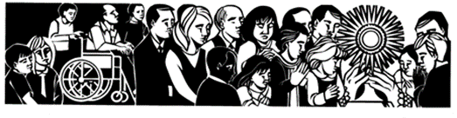

*“What you see…is bread and a cup.*

*This is what your eyes report to you.*

*But your faith has need to be taught*

*that the bread is the body of Christ,*

*the cup the blood of Christ…*

*If then, you wish to understand the body of Christ,*

*listen to the Apostle as he says to the faithful,*

*“You are the body of Christ and His members”*

*…You reply “Amen” to that which you are,*

*and by replying you consent…*

*Be a member of the body of Christ*

*so that your ‘Amen’ may be true…*

*Be what you see, and receive what you are.”*

*(Saint Augustine, Sermon 272)*

*The Liturgy of the Hours ©1975, International Committee on English in the Liturgy, Inc.  All rights reserved.*