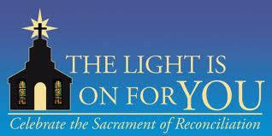

General Intercessions for the Universal Prayer:
- That Catholics in our Diocese will heed the Lord’s Lenten call to repentance and choose to participate in The Light is On For You celebration of reconciliation, to receive forgiveness in the Sacrament of Penance. We pray to the Lord…
- That Catholics who have been wounded by the church or fallen away from regular practice of their faith will feel welcomed and return to the Sacrament of Reconciliation during The Light is On For You process this Lent, in order to receive the Lord’s loving mercy and begin again. We pray to the Lord…

Intercessions for inclusion in the Universal Prayer each Lenten Sunday:
- February 26: That Catholics who have been away from the practice of the Sacrament of Confession will participate in the Diocesan celebration of Reconciliation, The Light is On For You, and come to be reconciled with God during the coming season of Lent. We pray to the Lord…
- March 5: That all us, aware of the temptation to sin, will come and receive Jesus’ loving mercy during the special Diocesan celebration of reconciliation, The Light Is On For You, Monday nights during Lent. We pray to the Lord…
- March 12: That all of us will heed God the Father’s command to listen to his Son, and act on his call to repentance by making a good confession during the Diocesan celebration of Reconciliation, The Light is On For You, Monday nights during Lent. We pray to the Lord…
- March 19: That each of us will notice our thirst for God, and welcome the graces offered to us during the Diocesan celebration of Reconciliation, The Light Is On For You, Monday nights during Lent. We pray to the Lord…
- March 26: That each of us, desiring to live the truth and come to the light, will make a good confession during the Diocesan celebration of Reconciliation, The Light is On For You, Monday nights during Lent. We pray to the Lord…

