DIOCESE OF SCRANTON

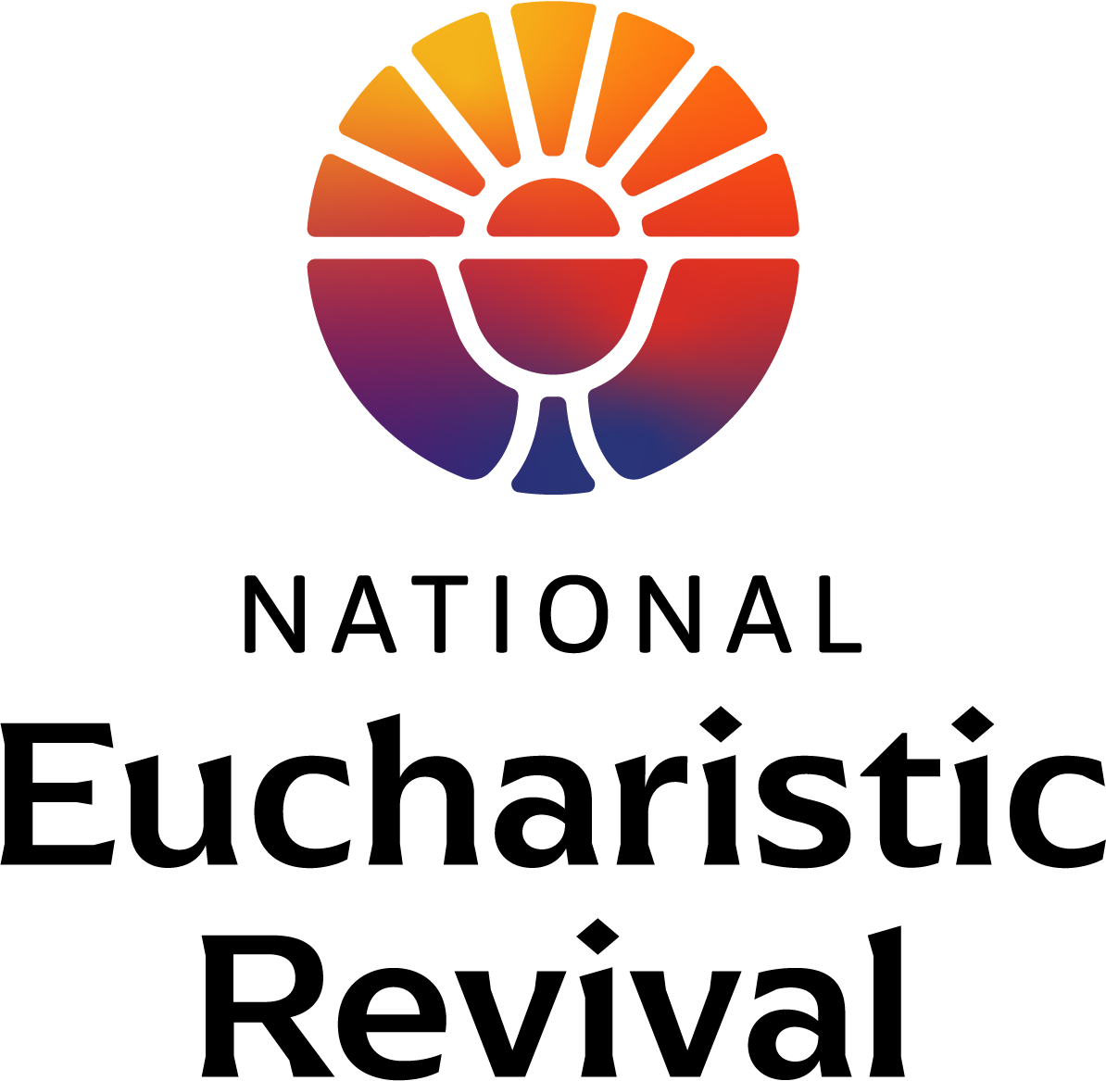

LENTEN HOLY HOUR

AS PART OF THE DIOCESAN OBSERVANCE OF THE
NATIONAL EUCHARISTIC REVIVAL

Homilist
The Most Reverend Joseph C. Bambera, D.D., J.C.L
Bishop of Scranton

EXPOSITION
OF THE BLESSED SACRAMENT

STAND

Procession of the Ministers
All stand while the ministers and the Bishop process to the sanctuary. Once there, the presiding minister goes to the tabernacle.

KNEEL

EXPOSITION HYMN
The presiding minister takes the Blessed Sacrament from the tabernacle and places it in the monstrance on the altar. All kneel. The Blessed Sacrament is then incensed while the Exposition Hymn is sung by the faithful.

SILENT ADORATION
Follow the Exposition Hymn, the faithful are encouraged to spend some time in quiet prayer before the Lord in the Blessed Sacrament. After a suitable amount of time, the Holy Hour continues with Vespers.

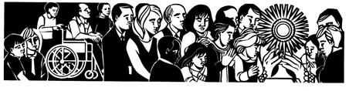
VESPERS

STAND

INTRODUCTORY DIALOGUE

All stand and make the Sign of the Cross.

Presider: God, come to my assistance.
All: Lord, make haste to help me.
Presider: Glory to the Father, and to the Son,
and to the Holy Spirit:
All: as it was in the beginning,
is now, and will be for ever. Amen.

Hymn
An appropriate hymn is sung. After the hymn, all are seated for the Psalmody.

SIT

Psalmody

Presider: The Lord is compassionate: he give food to those who fear him as a remembrance of his great deeds.

Psalm 111
God’s marvelous works
We are lost in wonder at all that you have done for us, our Lord and mighty God (Revelation 15:3).

I—Left Side II—Right Side

I I will thank the Lord with all my heart
in the meeting of the just and their assembly.
Great are the works of the Lord;
to be pondered by all who love them.

II Majestic and glorious his work,
his justice stands firm for ever.
He makes us remember his wonders.
The Lord is compassion and love.
I He gives food to those who fear him;
keeps his covenant ever in mind.
He has shown his might to his people
by giving them the lands of the nations.

II His works are justice and truth:
his precepts are all of them sure,
standing firm for ever and ever:
they are made in uprightness and truth.

I He has sent deliverance to his people
and established his covenant for ever.
Holy his name, to be feared.

II To fear the Lord is the first stage of wisdom;
all who do so prove themselves wise.
His praise shall last for ever!

I Glory to the Father, and to the Son,
and to the Holy Spirit:

II As it was in the beginning, is now,
and will be forever. Amen.

All: The Lord is compassionate: he give food to those who fear him as a remembrance of his great deeds.

Presider: The Lord brings peace to his Church, and fills us with finest wheat.

Psalm 147:12-20
Come, I will show you the bride of the Lamb
(Revelation 21:9).

I—Left Side II—Right Side

I O praise the Lord, Jerusalem!
Zion, praise your God!
II He has strengthened the bars of your gates,
he has blessed the children within you.
He established peace on your borders,
he feeds you with finest wheat.

I He sends out his word to the earth
and swiftly runs his command.
He showers down snow white as wool,
he scatters hoar-frost like ashes.

II He hurls down hailstones like crumbs.
The waters are frozen at his touch;
he sends forth his word and it melts them:
at the breath of his mouth the waters flow.

I He makes his word known to Jacob,
to Israel his laws and decrees.
He has not dealt thus with other nations;
he has not taught them his decrees.

II Glory to the Father, and to the Son,
and to the Holy Spirit:

I As it was in the beginning, is now,
and will be forever. Amen.

All: The Lord brings peace to his Church, and fills us with finest wheat.

Presider: You are the way, the truth and the life of the world, O Lord.

Canticle
Revelation 11:17-18; 12-10b-12a
The judgment of God

I—Left Side II—Right Side

I We praise you, the Lord God Almighty,
who is and who was.
You have assumed your great power,
you have begun your reign.

II The nations have raged in anger,
but then came your day of wrath
and the moment to judge the dead:
the time to reward your servant the prophets
and the holy ones who revere you,
the great and the small alike.

I Now have salvation and power come,
the reign of our God and the authority
of his Anointed One.
For the accuser of our brothers is cast out,
who night and day accused them before God.

II They defeated him by the blood of the Lamb
and by the word of their testimony;
love for life did not deter them from death.
So rejoice, you heavens,
and you that dwell therein!

I Glory to the Father, and to the Son,
and to the Holy Spirit:

II as it was in the beginning, is now,
and will be forever. Amen.

All: You are the way, the truth and the life of the world, O Lord.

Reading 1 Corinthians 11:23-26

“For as often as you eat this bread and drink the cup,
you proclaim the death of the Lord until he comes.”

Homily Most Reverend Joseph C. Bambera

Responsory

Reader: The living Father has sent me
and I have life from the Father.
Whoever eats my flesh has life from me.

All: The living Father has sent me
and I have life from the Father.
Whoever eats my flesh has life from me.

Reader: The Lord has fed us on the bread of life and understanding

All: Whoever eats my flesh has life from me.

Reader: Glory be to the Father, and to the Son, and to the Holy Spirit.

All: The living Father has sent me
and I have life from the Father.
Whoever eats my flesh has life from me.

STAND

Canticle of Mary

Saint Meinrad Archabbey Tone 8
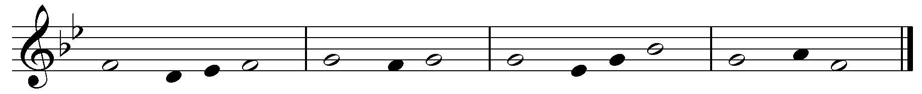

Cantor: How holy this feast in which Christ is our food;
his passion is recalled;
grace fills our hearts;
and we receive a pledge of the glory to come.

All make the Sign of the Cross while singing:

All: My soul proclaims the greatness of the Lord,
my spirit rejoices in God my Savior
for he has looked with favor
on his lowly servant.

From this day all generations
will call me blessed:
the Almighty has done great things for me
and holy is his Name.

He has mercy on those who fear him
in every generation.
He has shown the strength of his arm,
he has scattered the proud in their conceit.

He has cast down the mighty from their thrones,
and has lifted up the lowly.
He has filled the hungry with good things,
and the rich he has sent away empty.

He has come to the help of his servant Israel
for he has remembered his promise of mercy,
the promise he made to our fathers,
to Abraham and his children for ever.

Glory to the Father, and to the Son,
and to the Holy Spirit:
as it was in the beginning is now,
and will be forever. Amen.

Antiphon: How holy this feast in which Christ is our food;
his passion is recalled;
grace fills our hearts;
and we receive a pledge of the glory to come.

INTERCESSIONS

Presider: Christ invites all to the supper in which he gives his body and blood for the life of the world. Let us ask him:

All: Christ, the bread from heaven,
grant us everlasting life.

Reader: Christ, Son of the living God, you commanded that this thanksgiving meal be done in memory of you, enrich your Church through the faithful celebration of these mysteries.

All: Christ, the bread from heaven,
grant us everlasting life.

Reader: Christ, eternal priest of the Most High, you have commanded your priests to offer your sacraments, may they help them to exemplify in their lives the meaning of the sacred mysteries which they celebrate.

All: Christ, the bread from heaven,
grant us everlasting life.

Reader: Christ, bread from heaven, you form one body out of all who partake of the one bread, refresh all who believe in you with harmony and peace.

All: Christ, the bread from heaven,
grant us everlasting life.

Reader: Christ, through bread you offer the remedy for immortality and the pledge of future resurrection, restore health to the sick and living hope to sinners.

All: Christ, the bread from heaven,
grant us everlasting life.

Reader: Christ, our king who is to come, you commanded
that the mysteries which proclaim your death be celebrated until you return, grant that all who die in you may share in your resurrection.

All: Christ, the bread from heaven,
grant us everlasting life.

THE LORD’S PRAYER

BENEDICTION
OF THE BLESSED SACRAMENT

KNEEL

BENEDICTION HYMN
The presiding minister goes to the altar, genuflects, and then kneels. The Benediction Hymn is sung while the presiding minister incenses the Blessed Sacrament.

PRAYER

Presider: Let us pray.

O God, who in this wonderful Sacrament
have left us a memorial of your Passion,
grant us, we pray,
so to revere the sacred mysteries
of your Body and Blood
that we may always experience in ourselves
the fruits of your redemption.
Who live and reign with God the Father
in the unity of the Holy Spirit,
God for ever and ever.

All: Amen.

THE EUCHARISTIC BLESSING
The presiding minister puts on the humeral veil covering his hands signifying that is it Christ present in the Eucharist who is giving the blessing.

REPOSITION OF THE BLESSED SACRAMENT
After the blessing, the presiding minister removes the humeral veil. He then removes the Blessed Sacrament from the monstrance and places the consecrated host back in the tabernacle. Meanwhile the faithful recite the Divine Praises.

All: Blessed be God.
Blessed be His Holy Name.
Blessed be Jesus Christ, true God and true Man.
Blessed be the Name of Jesus.
Blessed be His Most Sacred Heart.
Blessed be His Most Precious Blood.
Blessed be Jesus in the Most Holy Sacrament of the Altar.
Blessed be the Holy Spirit, the Paraclete.
Blessed be the great Mother of God, Mary most Holy.
Blessed be her Holy and Immaculate Conception.
Blessed be her Glorious Assumption.
Blessed be the Name of Mary, Virgin and Mother.
Blessed be St. Joseph, her most chaste spouse.
Blessed be God in His Angels and in His Saints.

STAND

CLOSING HYMN
Once the Blessed Sacrament has been placed back in the tabernacle and the tabernacle door closed, the assembly stands and sings an appropriate hymn.

Artwork by Sr. Jeanne Ambre, SS. C.M.

“What you see…is bread and a cup.
This is what your eyes report to you.
But your faith has need to be taught
that the bread is the body of Christ,
the cup the blood of Christ…
If then, you wish to understand the body of Christ,
listen to the Apostle as he says to the faithful,
“You are the body of Christ and His members”
…You reply “Amen” to that which you are,
and by replying you consent…
Be a member of the body of Christ
so that your ‘Amen’ may be true…
Be what you see, and receive what you are.”

(Saint Augustine, Sermon 272)

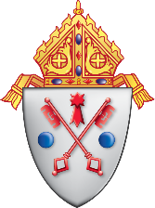

DIOCESE OF SCRANTON

300 Wyoming Avenue
Scranton, Pennsylvania 18503
www.dioceseofscranton.org

