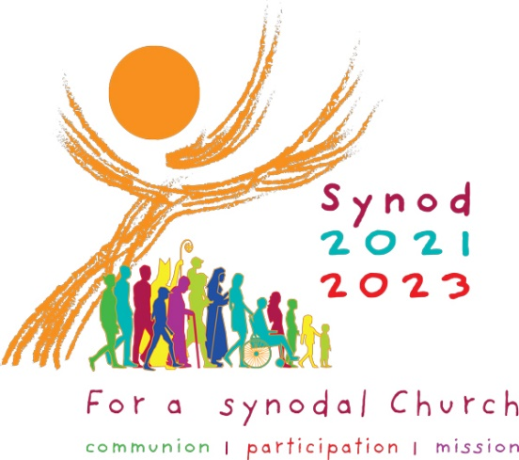 Synod on Synodality Survey

1. In the Church and in society, we are called to walk together, side-by-side, as we journey through life.

The Catholic Church in the Diocese of Scranton is inclusive, meaning every person has the ability to participate as equals.

Strongly Agree
Agree
Disagree
Strongly Disagree
No Opinion

We invite you to provide any thoughts on groups or individuals who you feel the Catholic Church may be leaving on the margins.

2. Listening is one of the most powerful and deeply human experiences we can have. The act of listening respects and validates the voice that is being heard.

The Catholic Church in the Diocese of Scranton listens to all people.

Strongly agree
Agree
Disagree
Strongly Disagree
No Opinion

We invite you to provide any additional thoughts on those that the Catholic Church does/does not listen to.

3. Catholics in the Diocese of Scranton are encouraged to speak up, be brave and boldly trust we are loved by God.

Catholics in the Diocese of Scranton are provided with the opportunity to speak candidly with their parish priest and our bishop.

Strongly agree
Agree
Disagree
Strongly Disagree
No Opinion
We invite you to provide any additional thoughts on what enables or hinders people from speaking up about their hopes and concerns.

4. One of the foundations of the Catholic faith is the belief that God is alive in each and every human person. For Christians, we are baptized and anointed with the Holy Spirit and are nourished by Christ in the Eucharist.

The celebration of the Mass inspires me toward a more joyful and holier life.

Strongly agree
Agree
Disagree
Strongly Disagree
No Opinion

We invite you to provide any additional thoughts on how prayer and/or Masses do or do not inspire you.

5. Every Catholic has a responsibility to participate actively in the mission of the Catholic Church, sharing the Good News of Jesus Christ.

The Catholic Church in the Diocese of Scranton is succeeding in the following areas of its mission:
Strongly Agree Agree Disagree Strongly Disagree

- Leading People to a Deeper Relationship with God
- Educating People of All Ages in the Faith
- Helping the Poor, Lonely and Vulnerable
- Welcoming Immigrants, Refugees and Other Newcomers
- Being Compassionate to those in Prison
- Ensuring Racial Equality
- Promoting Pro-Life Issues
- Protecting Human Rights
- Caring for the Environment
- Supporting Families

We invite you to provide any additional thoughts on where the mission of the Church is in need of greater focus.

6. From Pope Saint Paul VI to Pope Francis, successive popes have actively called the People of God to be a Church in dialogue. Through dialogue, all of the Christian faithful shape the way the Church achieves her mission.

Catholics in the Diocese of Scranton are provided with the opportunity to discuss, debate and dialogue about the future direction of the church.

Strongly agree
Agree
Disagree
Strongly Disagree
No Opinion

We invite you to provide any additional thoughts on the places and opportunities that our church does or does not offer for constructive dialogue.

7. Christ calls all His disciples, united by Baptism, to work side-by-side with diverse groups and other faith communities.

It is a priority of the Catholic Church in the Diocese of Scranton to work with other faith communities in promoting the well-being of all.

Strongly agree
Agree
Disagree
Strongly Disagree
No Opinion

We invite you to provide any additional thoughts on the way the Catholic Church could interact with other Christian denominations and/or individuals with no faith tradition.

8. Through Baptism and Confirmation, the mission of the Catholic Church belongs to all the Christian faithful. Everyone is called to play an active role.

All Catholics, including young people, lay men and lay women, are challenged to use their gifts and talents in the life of the Church.

Strongly agree
Agree
Disagree
Strongly Disagree
No Opinion

We invite you to provide any additional thoughts on how people are/are not invited to participate in the life of the Church.

9. The Christian faith is accessible to everyone. Because the mission of the Catholic Church belongs to the Church's members, every voice has a right to be heard.

In making important decisions, the Catholic Church in the Diocese of Scranton is transparent and accountable in its decision-making processes.

Strongly agree
Agree
Disagree
Strongly Disagree
No Opinion

We invite you to provide any additional thoughts on the decision-making process that the church uses and how it can be improved.

10. The Church's Tradition, received from the Apostles, carries the Christian faith through history. A synod is meant to identify the needs, challenges and opportunities of the present moment.

While respecting Tradition, the Catholic Church in the Diocese of Scranton is responsive to the needs, challenges and opportunities at the present moment.

Strongly agree
Agree
Disagree
Strongly Disagree
No Opinion

We invite you to provide any additional thoughts on how the church listens and engages in dialogue.

DEMOGRAPHICS
What is your gender?
Female
Male

What is your age?
Under 18
18-30
31-45
46-65
65-80
80 or older

Which race/ethnicity best describes you? (Please choose only one.)
American Indian or Alaskan Native
Asian / Pacific Islander
Black or African American
Hispanic
White / Caucasian
Multiple ethnicity / Other (please specify)

In which County do you currently reside?
Bradford
Lackawanna
Luzerne
Lycoming
Monroe
Pike
Sullivan
Susquehanna
Tioga
Wayne
Wyoming
Do not currently reside in the Diocese of Scranton

If you currently belong to a parish in the Diocese of Scranton, please indicate which parish:

