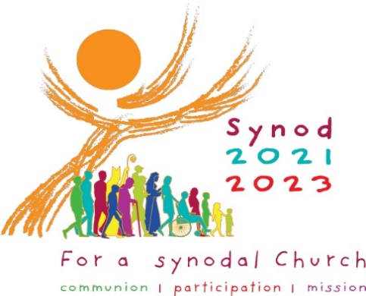 Gathered Listening Conversation Guide
________________________________________________________________________________

Introduction: Please know how grateful we are for your participation in this process. As you begin your “Listening Conversation” please let this tool serve as a guide as we discern new ways of being Church together … whether you are facilitating a group as a pastor, as a parish delegate or as an individual who wishes to have their voice included. As we begin this journey, it is our sincere desire to engage the people of God in our diocese in conversation so that we can listen well to their thoughts and needs. We ask everyone to have the courage to speak boldly, freely and honestly.
The fundamental question for us as people of God is … “What steps does the Spirit invite us to take in order to grow in our journeying together”?
Let’s LISTEN and DISCERN together … How is God calling us to be a Christ-centered church?

How to use this Guide:

- The ten themes outlined below are those posed by our Holy Father, Pope Francis. Please base your conversations around any of these. Choose according to what resonates in your community: one theme, three themes, or all ten.

- Please use whichever language best captures these themes for your community. The words offered below are simply starting points. In order to best answer Pope Francis’ call, we ask you to stay as near as possible to the spirit of the themes he has offered. (To access these themes in full, please see The 10 Themes of the Synod on Synodality resource on the Diocesan Synod Webpages.)

- If you choose to take this gathering opportunity to add conversation themes that are pertinent specifically to your community, and which do not bear upon the ten stated themes of this Synod, we ask that you note that in the report you submit to the Diocesan Synod Team.

 | Themes | Prompts for Consideration …  The Catholic Church in the Diocese of Scranton: | Guiding Thoughts
1. | Companions on the Journey | Is inclusive, meaning every person has the ability to participate as equals | In our local church who are those who walk together  Who are left on the margins
2. | Listening | Listens to all people | How well do we listen to those on the peripheries  How are the laity listened to … women … young people
3. | Speaking Out | Provides the opportunity to speak candidly to church leaders | What enables or hinders our speaking up  How do we manage to say what is important to us
4. | Celebration | Does the Mass inspire us toward a more joyful and holier life | How do we promote the active participation of all the faithful at liturgy
5. | Sharing Responsibility for  our Common Mission | Is succeeding in the following areas of its mission (See List*) | How is every person called to participate in the mission of the church  What areas of mission are we neglecting
6. | Dialogue in Church and Society | Provides the opportunity for all people to discuss, debate and dialogue on the future direction of the church | What are the places and means of dialogue within our local church  How do we promote collaboration with others
7. | Ecumenism | Is it a priority of our local church community to work with other faith communities in promoting the well-being of all | What relationships does our church community have with other traditions and denominations  How can we take next steps in walking together
8. | Authority and Participation | Are we (including young people, lay men and lay women challenged to use our gifts and talents in the life of the church | How is teamwork and co-responsibility put into practice How can we foster a more synodal approach in our participation and leadership
9. | Discerning and Deciding | Is transparent and accountable in its decision-making processes | What methods or processes do we use in decision making  How can they be improved
10. | Forming Ourselves in Synodality | Is the Catholic church receptive to change | How does our church community form people to be more capable of “walking together”, listening to one another and engaging in dialogue

*List for Theme 5: Sharing Responsibility for our Common Mission
- Leading People to a Deeper Relationship with God
- Educating People of All Ages in the Faith
- Helping the Poor, Lonely and Vulnerable
- Welcoming Immigrants, Refugees and Other Newcomers
- Being Compassionate to those in Prison
- Ensuring Racial Equality
- Promoting Pro-Life Issues
- Protecting Human Rights
- Caring for the Environment
- Supporting Families

Please list any additional themes or questions that were discussed or that arose:

