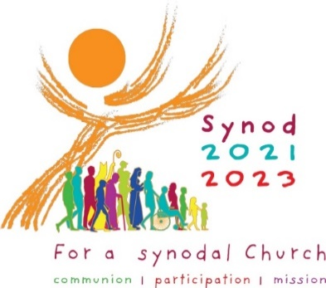 Parish and Community Gathered Listening Report
___________________________________________________________________
Thank you for gathering with your community and helping our local and Universal Church hear the voices of your people. We pray this has been a fruitful experience for you.
Please submit your community’s Listening Report to our Diocesan Synod Team by no later than April 1, 2022. The parish and community reports we receive will help to inform Bishop Bambera’s Gathered Listening Event in May 2022.
Some suggestions for how you may create your report are listed below:
How shall we collect the responses from our gathering for the report?
If your community is able to provide persons to act simply as listeners and recorders, that would be ideal. These persons will simply focus on taking in and hearing the conversation, and then will write/type what he/she heard and observed.
Gathered Listening facilitators can also act as listeners and recorders if necessary. These persons will not only help to lead and guide the listening conversation, but they will also fulfill the duties outlined above.
What information should be included in the report? (Use the preformatted Report Template found here.)
- A brief written summary of the details of your gathered listening event
    - Date/time/location/duration/format
    - How many attended
    - Which persons participated (approximate ages, genders, families/singles, ethnicities, etc.)
- A written record of the responses shared
- The general sense of how your community responded to this process
- A record of any particularly compelling statements, shared experiences, or concerns that were raised. When possible, include direct quotations or specific responses paraphrased
- Consider the questions below in reference to the themes your community discussed as you compile your report:
        - Which themes were most significant for your community, why?
        - What were some of the high points, some of the positive and rewarding expressions from your community?
        - What were some of the low points, some of the struggles or tensions expressed by your community?
        - Which fruits of this process are the most meaningful for your community?
If the Office for Parish Life can be helpful to you as your community creates and submits your report, please reach out. We are glad to help.
By April 1, 2022, please submit your completed parish or community report to synod@dioceseofscratnon.org or to Jen Housel, jhousel@diocesofscratnon.org (570-207-2213 x 1104)

