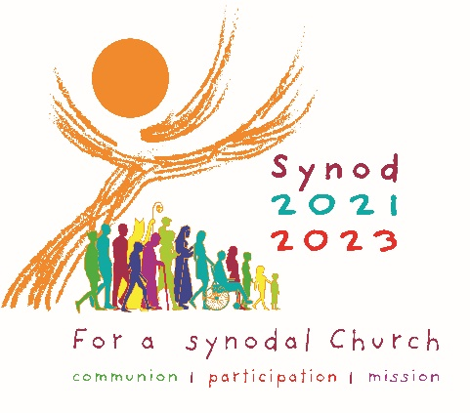
Synod on Synodality
Reaching Out to the Marginalized

Our Holy Father, Pope Francis, seeks to hear every voice and asks us to take particular care in including those often marginalized or left out. Your community leaders likely know best which marginalized persons could be sought out and particularly invited to your listening process to gather responses that can be fruitful for your community, for our local Church, and for our Church Universal. Below are some ideas for seeking and inviting those who are marginalized in our parishes and communities. Remember, the Prayer of the Synod asks the Holy Spirit to help us find our unity so that we may journey together to eternal life. Reaching out to the marginalized in our parish and society helps us accomplish just that.

Those who struggle with poverty

Does your parish or community have a food pantry or support a nearby food pantry? Consider having volunteers from your community have a discussion with or interview those who rely on the support of the pantry using the Synod survey prompts. The interview can even happen during a normal food distribution or pickup.

Those who have disabilities

Identify those individuals in your parish that have disabilities or special needs and make a conscious effort to personally invite them to the parish or community listening session. Respect their needs to communicate openly and effectively during the session. For ideas on how to become a more welcoming parish or community to persons with disabilities, click here.

Those who have chronic illnesses or addictions

Do your extraordinary ministers of Holy Communion take the sacrament to homebound persons with chronic illnesses? Invite the lay ministers to have a discussion with the chronically ill using the Synod survey after they receive the Eucharist. This is another way of extending the parish community’s care and support.

Does your parish host Alcoholics Anonymous (A.A.) meetings? Ask some of the attendees if they would like to participate in the survey, or if they know anyone currently struggling with addiction who might like to participate in the Synod discussion.

Those who identify with a marginalized race, gender, or sexual orientation

Think about those individuals in your parish who may come to church, but feel like an “outsider” to the community for various and private reasons. Personally invite them to the parish or community listening session, or meet with them to discuss the prompts found on Synod survey or their reasons for feeling outside of the community.

Unmarried young people

Identify the young adults of your parish, ages 21-35, and consider inviting them, personally and through social media, to a “Theology on Tap” event at a local establishment where you would discuss the prompts of the Synod survey.

Those who have fallen away from the church

Does your parish have an “inactive” list of parishioners? Reach out to some of them, and see if they would be willing to meet and have a discussion about why they choose not to come to church. Weave the prompts of the Synod survey into your discussion with them.

Young families who have not returned to the community after their wedding
or after their child’s Baptism, First Communion, or Confirmation

As pastor, you probably know which couples have not returned to the parish following their wedding. You most likely still have their contact information—reach out to them and find out where they are at in their Catholic faith using the Synod survey as a foundation.

Your parish Director of Religious Education can most likely identify those families who only come to church during their child’s sacramental year. Contact them and see if they would be willing to have a discussion about what their faith means to them and about the future of the Catholic Church using the survey as a model.

Those who have not returned to community worship since the pandemic began

We can most likely identify many of those who have not returned to church since the COVID-19 pandemic began. Now may be a good time to contact them and say that the Church needs their presence and input. Encourage them to attend the listening experience in the parish, and welcome them back to church.

