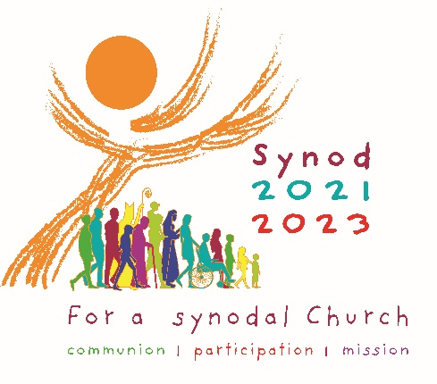
Synod on Synodality
Bulletin Announcements

The following bulletin announcements are meant to promote
your parish participation in the listening phase of the Synod.
Please use these announcements in your bulletin and in social media in the weeks leading up to your parish consultation gathering.

Synod and the Act of Listening
A voice has no power unless it is listened to. Listening is one of the most powerful and deeply human experiences that we can have because the act of listening respects and validates the voice that is being heard. Being listened to satisfies the deepest longings of the human heart. In short, we affirm one another’s dignity and inherent creativity through the process of listening. For better or worse, words are powerful. And when the spoken word expresses something authentic, if not heard, cannot bear fruit in the world. Authentic listening is an act of love.
Throughout her history, the Church values the art of listening. From the earliest days of Christianity, the Church has used the model of a Synod, or the concept of Synodality, as a means of listening to the voice of Christ alive in the Church’s members.

What Is a Synod?
Like many of the words that we use in our Catholic tradition, Synod is an ancient Greek word that means assembling to determine the path forward. A Synod is a Process that gathers Christ’s disciples so that their voices can be heard. It is the Church’s belief that each and everyone’s voice is that of Christ. And when two or three of Christ’s Faithful are gathered, he is present and alive in their midst.
The history of the Church also shows us that the model of Synodality was a critical tool at times of crisis and challenge. A particular ‘synod’ was called to address various crises in the life of the Church and history tells us that, in those moments, the presence of the Holy Spirit was alive in their midst, leading the Church forward. The model of a Synod allows the presence of Christ to be given voice at this moment in our history.

The 2021-2023 Synod of Bishops
On March 7, 2020, Pope Francis announced that a Synod of Bishops would convene at the Vatican in October 2023, the theme of which will be For a synodal Church: communion, participation and mission. As a vital first step in the Synod process, the Holy Father has invited each diocese around the world to listen to the voices of its people including those who are marginalized or may have fallen away from the Church.
By virtue of our Baptism, all of us are called to be active participants in the life of the Church through discernment, participation and co-responsibility. Through a process of careful listening, our participation in the Synod process will enable us to better understand how the Christian community participates in the life of our Church in the Diocese of Scranton today and how that shared participation among our members might grow in the future.
(From Bishop Bambera’s Letter to the Faithful, October 4, 2021)

The 2021-2023 Synod on Synodality
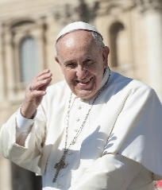
By calling for the 2021-2023 Synod on Synodality, Pope Francis is inviting the Church to gather and to listen to each and every Catholic to find the Church’s path forward at this time in our history. This is a moment for the voice of God’s people to be heard to give voice to the direction of the Church. Pope Francis is providing the opportunity for this ancient and tested model to find relevance in light of today’s challenges and opportunities.
The Holy Father seeks to hear every voice. Prayerfully consider participating in your parish’s in-person consultation session or through the online survey at www.dioceseofscranton.org.

The Synod and Journeying Together
Far from being a temporary or one-time experience in calling the Church to participate in the Synod process, Pope Francis is reminding us that the very mission of the Church requires the entire People of God to be on a journey together, with each member playing his or her crucial role, united with each other. The Holy Father’s hope is that the experience of this unique world-wide opportunity will bring about a new springtime for listening, discernment, dialogue and decision-making in our Church, so that the whole People of God can better journey together with one another and the entire human family, under the guidance of the Holy Spirit.
(From Bishop Bambera’s Letter to the Faithful, October 4, 2021)

Prayer for the Synod

Adsumus Sancte Spiritus

We stand before You, Holy Spirit, as we gather together in Your name.
With You alone to guide us, make Yourself at home in our hearts;
Teach us the way we must go and how we are to pursue it.
We are weak and sinful; do not let us promote disorder.
Do not let ignorance lead us down the wrong path
nor partiality influence our actions.
Let us find in You our unity so that we may journey together to eternal life
and not stray from the way of truth and what is right.
All this we ask of You, who are at work in every place and time,
in the communion of the Father and the Son, forever and ever.
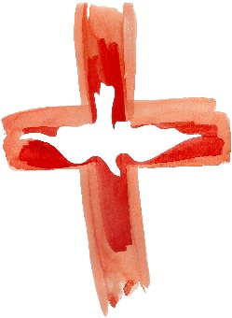
Amen.

