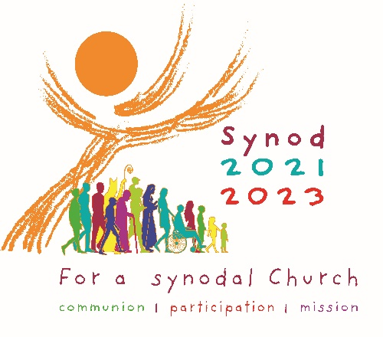
Sample Intercessions
for the Synod on Synodality

- For Francis our Pope, Joseph our Bishop, and the holy and faithful People of God in the Diocese of Scranton, that the celebration of the Synod may help us to discern God’s will and to boldly carry it out, let us pray to the Lord.

- For our Holy Father, Francis, our Bishop, Joseph, and all bishops and priests: that they may trust the work of the Holy Spirit and inspire all of the faithful, especially the poor and marginalized, to engage in the listening phase of the Synodal Process, let us pray to the Lord.

- That the Holy Spirit, working through the Synod of Bishops, may breathe the new life of hope into those deprived of freedom, devastated by hunger, or denied their human dignity, let us pray to the Lord.

- That our participation in the listening phase of the Synod may bring forth a spirit of renewal in the Church and unity among its members, let us pray to the Lord.

- That the local work of the Synod process may strive to make the voices of the faithful heard, especially those marginalized who are often excluded and forgotten, let us pray to Lord.

- For our parish community: that the Synodal Process may lead us ever deeper into the communion of the Church, foster our participation in it, and equip us to go out on mission, let us pray to the Lord.

- That the voices of the faithful expressed in the work of the Synod process may challenge the Church in its ongoing mission of Christian discipleship, let us pray to the Lord.

- That through the Synod of Bishops, all the Baptized may recognize their call to co-responsibility in the Church and work together in building the Kingdom of God, let us pray to the Lord.

- That the Synod of Bishops may bestow on all of the faithful, both the old and young alike, dreams of peace and visions of justice, let us pray to the Lord.

- That as our parish participates in the Synodal Process, we may faithfully listen to the Holy Spirit at work in our lives and in the Church, let us pray to the Lord.

