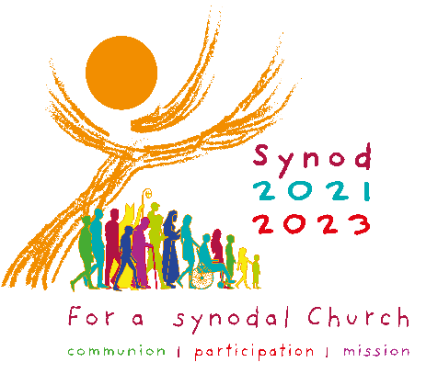
A Prayer Service for
the Synod on Synodality:
Listening to the Spirit

Focusing:
(Reader 1)
One of the most loving behaviors that we can offer each other is to be a good listener. Listening – not just with our ears, but also with our head and heart – is a truly powerful and deeply human experience. We acknowledge one another’s dignity and inherent creativity through the process of listening. Words are powerful. When the spoken word expresses something authentic, if it is not heard, it cannot bear fruit in the world.

(Reader 2)
Throughout her history, the Church has valued the art of listening. From the earliest days of Christianity, the Church has used the model of a Synod as a means of listening to the voice of Christ alive in each member of the Church. Put simply, a Synod is a process to gather Christ’s disciples to hear their voices.

Suggested Hymn: “Sing a New Church” (NETTLETON, words by Delores Dufner, OSB)

Scripture
(Reader 3)
“The wind blows where it chooses and you hear the sound of it, but you do not know where it comes from or where it goes. So it is with everyone who is born of the Spirit. (John 3:8)

(Reader 4)
When the time for Pentecost was fulfilled, they were all in one place together. And suddenly there came from the sky a noise like a strong driving wind, and it filled the entire house in which they were. Then there appeared to them tongues as of fire, which parted and came to rest on each one of them. And they were all filled with the Holy Spirit and began to speak in different tongues, as the Spirit enabled them to proclaim. (Acts 2:1-2)

Quiet Reflection

Leader: The Spirit can come as a gentle breeze: a breeze that enlivens us where we’ve become weary; a breeze that cools us where we’re overheated; a breeze that calms us when we’re overwrought; a breeze that refreshes what has become stale. Do we long for this breath of fresh air?

Take a moment to allow the Holy Spirit to prompt an awareness of aspects in the Church’s life where his gentle breeze needs to breathe in her.

Leader: The Spirit can come as a mighty wind; a wind that energizes us where we’ve become inactive; a wind that stirs up what is buried deep inside; a wind that carries us along and speeds our course; a wind that blows over our structures and defenses that keep God at a safe distance. Are we willing to welcome this wind?

Take a moment to allow the Holy Spirit to bring to attention aspects of the Church’s life where his powerful wind wants to blow through her.

Shared Reflection/Discussion on Questions

What are your hopes and dreams for the Church as it listens to its many members during this Synod?

Take a moment to prayerfully reflect on and discuss each question you are given.

Concluding Prayer
Prayer of the Synod
(Adsumus Sancte Spiritus)

We stand before You, Holy Spirit, as we gather together in Your name.
With You alone to guide us, make Yourself at home in our hearts;
Teach us the way we must go and how we are to pursue it.
We are weak and sinful; do not let us promote disorder.
Do not let ignorance lead us down the wrong path
nor partiality influence our actions.
Let us find in You our unity so that we may journey together to eternal life
and not stray from the way of truth and what is right.
All this we ask of You, who are at work in every place and time,
in the communion of the Father and the Son, forever and ever.

Amen.

