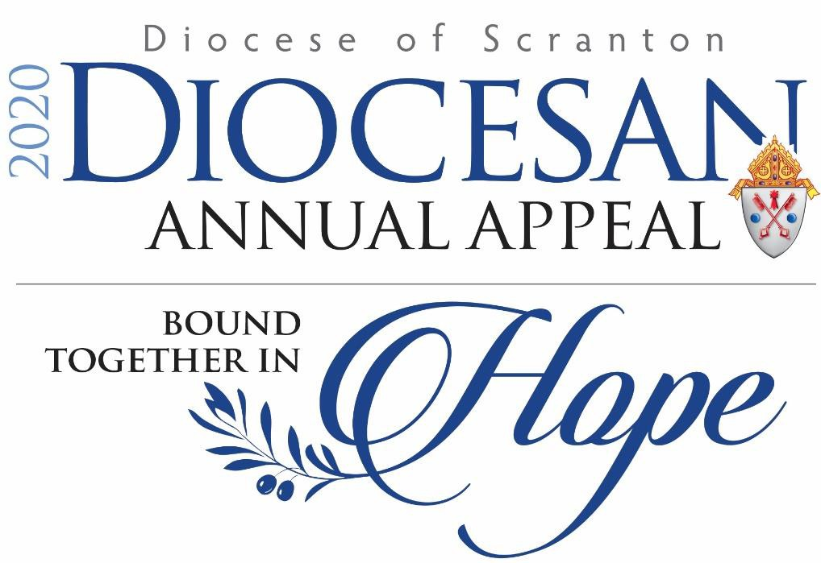

2020 PARISH MANUAL

TABLE OF CONTENTS

BISHOP’S MESSAGE 3
APPEAL TIMELINE & “ACTION EVENTS” 4
REGIONAL LAY AND CLERGY CHAIRS 5
MESSAGE TO PASTORS AND PARISH LIFE COORDINATORS 6
PARISH CAMPAIGN STRUCTURE, PARISH REPRESENTATIVES 9
THE APPEAL VIDEO – REGIONAL FEATURES 10
KEY APPEAL PROMOTION OPPORTUNITIES 11

Kick-Off Weekend – September 26 & 27

Promotion of Online Giving Weekend – November 21 & 22
DEVELOPMENT OFFICE CONTACTS 13

BISHOP’S MESSAGE

My dear friends, this has certainly been a difficult year, hasn’t it? We’ve faced separation, hardship and loss. Yet there are still so many good things taking place across our Diocese each and every day. We are truly blessed.

As we respond to the challenges of the pandemic in our families, our parishes and our Diocese, let us continue to turn our hearts to our one true hope – Jesus Christ. His love is unending, unfading, unshakable.

We are bound together in the Eucharist….bound together in hope.

Thank you for all that you are doing to keep our parishes strong. And thank you for your support of this year’s Diocesan Annual Appeal. With your help, we will continue to bring hope and love to one another.

Please know that I’m praying for you and your parishioners.

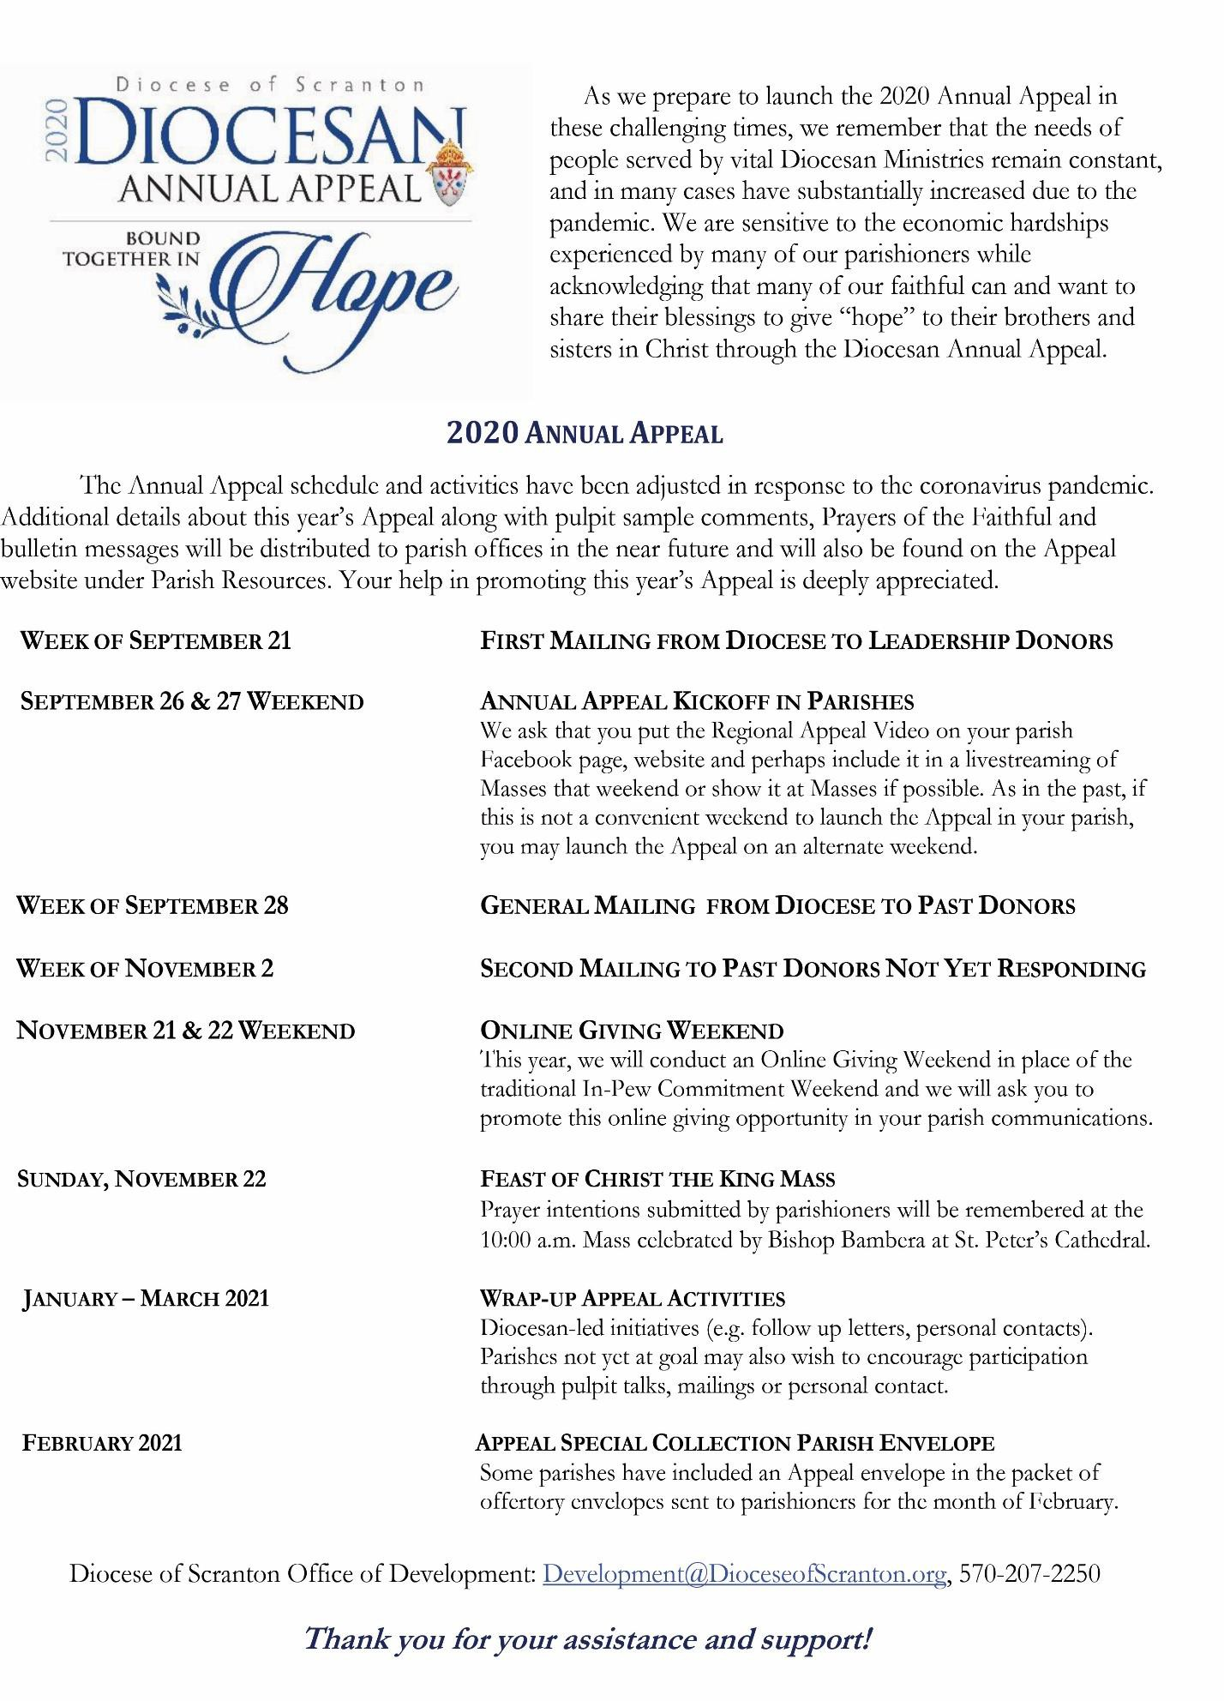

2020 APPEAL REGIONAL CHAIRS

BRADFORD, SULLIVAN AND SUSQUEHANNA COUNTIES
Karen Garman and Larry Hoey Epiphany Parish - Sayre Father Joseph Kutch St. Michael Parish, Canton

LACKAWANNA AND WYOMING COUNTIES
Chris and Ann DiMattio St. Catherine of Siena Parish – Moscow
Father Patrick Albert Nativity of the Blessed Virgin Mary Parish, Tunkhannock
and St. Mary of the Lake Parish, Lake Winola

LUZERNE COUNTY
Joe and Paula Panzitta Corpus Christi Parish, West Pittston

Father Joseph Elston St. John the Evangelist Parish and St. Joseph Marello Parish,
Pittston

LYCOMING AND TIOGA COUNTIES
Jim and Susan Dinsmore St. Lawrence Parish, Williamsport Father Glenn McCreary Resurrection Parish, Muncy

MONROE COUNTY
Atty. Joe and Linda McDonald Our Lady Queen of Peace Parish, Brodheadsville Father Carmen Perry St. Luke Parish, Stroudsburg

WAYNE AND PIKE COUNTIES
Gerald Najarian St. Vincent de Paul Parish – Milford

Father Ed Casey St. Ann Parish, Shohola and St. John Neumann Parish, Lords Valley

MESSAGE TO THE PASTOR & PARISH LIFE COORDINATOR

As we conduct the Annual Appeal, we recognize that the needs of people served by vital Diocesan Ministries remain constant, and in many cases have increased due to the pandemic. While we are sensitive to the economic hardships experienced by many of our parishioners and realize that some families may not be able to make an Appeal gift this year, we acknowledge that many of our faithful can and want to share their blessings to give “hope” to their brothers and sisters in Christ through the Diocesan Annual Appeal.

You play a significant role in encouraging support of the Diocesan Annual Appeal. As Pastors and Parish Life Coordinators, you set the tone for the effort in your parish with your endorsement and public support. Promoting the importance of supporting the Appeal and presenting the ministries benefitting from the Appeal are key elements of Appeal success. The impact of gifts to the Appeal is greater than ever before.

Because of the coronavirus pandemic, we have made some changes to this year’s Appeal that we hope will be helpful to you as you invite your parishioners to support the Appeal. These include delaying the start of the Appeal to the last weekend of September, the replacement of In-Pew Commitment Weekend with an Online Giving Weekend and the option to share the Appeal video at in-person Masses, as part of your taped or livestreaming of Masses and on your parish website and Facebook page.

GENERAL THEMES FOR THE 2020 APPEAL

In addition to focusing on this year’s Appeal theme: “Bound Together in Hope”, you may wish to speak about our mission and vision to serve others, particularly during challenging times.

The foundation and measure of our Catholic faith is following the example of Jesus to serve others
– the more we follow Jesus, the more fulfilled and joyful we are. Giving to others provides all of us with an opportunity to embrace the pattern of Jesus’ life, a life rooted in compassion, service & love. We are called to share the goodness of our faith with an understanding heart to accompany others in times of need.

When talking about the Appeal, some of our pastors incorporate Gospel messages about the rewards of giving – grow closer to God, feel peace in our hearts and become stronger disciples of Jesus.

Jesus said …give to [the] poor, and you will have treasure in heaven. Then come, follow me.” Matthew 19:21

They that hope in the LORD will renew their strength, they will soar on eagles’ wings;
They will run and not grow weary, walk and not grow faint. Isaiah 20:31

‘Amen, I say to you, whatever you did for one of these least brothers of mine, you did for me.’ Matthew 25:40

May the God of hope fill you with all joy and peace in believing, so that you may abound in hope by the power of the Holy Spirit. l Romans 15:13

DIOCESAN MINISTRIES AND THE IMPACT OF THE PANDEMIC

The main ministries supported by gifts to the Annual Appeal are:

- Parish Social Justice Grants and New Faith Formation Grants
- Catholic Social Services
- Catholic Education in Schools
- Care and Support for Retired and Ill Priests
- Clergy Formation for Seminarians and Deacons
- Parish Life and Ministry Formation
- Catholic Media and Communication

Mention new and increased needs and ways the Diocesan ministries are responding to the pandemic:

- We are serving an increased number of families in our Catholic Social Services and parish food pantries and material assistance programs. Catholic Social services pantries in Carbondale, Hazleton, Scranton and Wilkes-Barre saw an increase of 50% from March to July, 2020.

- So many parishioners shared their appreciation for the livestreaming of Masses from the Cathedral of St. Peter on the Diocesan website and the broadcast of Masses and special prayer services and vigils on Catholic TV. More than 50,000 people livestreamed the Mass from the Cathedral during the past several months.

- Significant adjustments were made in our Catholic schools in March to quickly move to distance learning and our faculty and staff worked throughout the summer so that we may continue to provide a quality education for our students in the safest way possible with both in-person classes and virtual learning options.

- The Office of Parish Life is offering some key programs in a virtual format such as the Catechist Camp for directors of religious education and the new “Together Project” to keep young adults connected. And a new virtual faith formation program with the focus on involving families is being provided to parishes.

You may wish to share in general terms the challenges facing the Diocese and parishes as a result of the pandemic – staff and budget reductions, increased expenses, etc. Remember, donors that are able to give want to help.

SUGGESTIONS AS YOU CONDUCT THE APPEAL

  - Invite parishioners to joyfully share in the work of the local Church by supporting the Annual Appeal as they strive to be true Disciples of Christ. Stress the importance of raising funds for the ministries of the Annual Appeal as a part of stewardship and how it fits with our call to return our gifts to the Lord in gratitude by sharing our blessings justly and charitably.

  - Personalize the message for the parishioner. Reflect on the reasons why you support the Appeal, and consider sharing that you’ve made your gift to the Appeal.

- List How Appeal Funds Assist Your Parish
Explain how funds from the Annual Appeal directly help your parish through Parish Life programs, religious education, care of a retired priest who served your parish or in support of a seminarian or recently ordained priest who has served your parish.

Refer to any Social Justice Grants your parish may have received from the Diocese and how the grants are being used; cite future programs your parish might pursue with such funds.

Talk about the new Parish Faith Formation Grants funded by the Appeal.

- Let your parishioners know that they are invited to submit a prayer intention throughout the Appeal campaign on all pledge forms past donors will receive in the mail, on the Diocesan online giving page at www.annualappeal.org and during the Online Giving Weekend on November 21 and
22. Depending on when prayer intentions are received, intentions will be remembered at Mass celebrated by Bishop Bambera at the Cathedral of St. Peter on either November 22 or on January
10. Parishioners do not have to make a gift to the Appeal to submit a prayer intention.

Promote the fact that 75% of the Appeal collections received over your Parish goal are returned to your Parish. Mention rebates and what the money could be used to fund in your parish, if attained. Announcing that you plan to use your rebate for a specific purpose may enhance giving.

- Ask every family to consider giving something to help you reach your parish goal. Two thirds of the gifts to the Appeal are $100 or less, so every gift matters.

  - Say “Thank You” to your past contributors.

PARISH CAMPAIGN STRUCTURE

PARISH LEADERSHIP

Pastors and Parish Life Coordinators provide the leadership for the Appeal but can also benefit from the invaluable assistance and influence of enthusiastic and committed Regional Chairs and Parish Representatives.

REGIONAL CHAIRS

To assist with the Annual Appeal, Bishop Joseph Bambera invites parishioners and clergy to serve as Regional Chairs, representing the six regions of the Diocese: 1) Bradford, Sullivan and Susquehanna Counties, 2) Lackawanna and Wyoming Counties, 3) Luzerne County, 4) Lycoming and Tioga Counties, 5) Monroe County, and 6) Wayne and Pike Counties.

Regional lay and clergy chairs give significantly of their time, talent and treasure to assist with the Annual Appeal. Regional chairs provide ideas for the Appeal and invite others to join with them in making a leadership gift to the Annual Appeal. They also promote the Appeal in their parishes.

PARISH REPRESENTATIVES

Parish Representatives serve as delegates to an Annual Appeal Regional Committee which meets two or three times during the length of the campaign. During regional meetings, Parish Representatives share experiences and suggestions with others to help enhance the Annual Appeal in our parishes.

Parish representatives are asked to:
- Attend two to three virtual Regional Committee meetings between September and February.
- Make an Annual Appeal gift.
- Work with pastor and parish staff to coordinate Diocesan Annual Appeal efforts in your parish to include showing the video during Kickoff Weekend, assisting with promoting the Online Giving Weekend, and helping to create opportunities to involve parishioners.
- Serve as a primary contact in your parish to provide updates on Annual Appeal activities and progress toward goal and to answer any questions.
- Personally consider contacting a small number of friends or potential donors (perhaps parishioners who are involved in leadership positions – finance or pastoral council members, Eucharistic ministers, lectors, choir members) to ask them to make a gift to the Diocesan Annual Appeal.
- Share the responsibility with the pastor/parish life coordinator to speak at in-person, taped or livestreamed Masses (or recruit volunteers to speak) on one or two weekends during the Campaign, perhaps prior to the Online Giving Weekend, to encourage parishioners to make an Appeal gift.
- Consider putting together a Parish Appeal Committee to help make contact with parishioners and ask for support.

REGIONAL VIDEO FEATURES
Due to the positive response received last year, for this 2020 campaign we again produced six different versions of the video for parishes to use on Appeal Kickoff Weekend during Mass, on your websites, and in all your social media outlets. These videos feature pastors, parishioners and special activities - including Social Justice programs – specific to each region.

The following Diocesan Ministries will appear in all six versions of the video:
- Catholic Social Services Food Pantries in Carbondale and Hazleton
- Catholic Media – The Daily Mass at St. Peter’s Cathedral
- Office of Parish Life - Virtual Cathechist Camp for DREs & Together Project for Young Adults
- Newly Ordained and Retired Clergy
- Diocesan Catholic Schools
- Social Justice Grants to Parishes

Bradford/Sullivan/Susquehanna Region
- Grandmother of students at Epiphany Elementary School, Sayre
- Monsignor John Esseff, Former Diocesan Director of Pontifical Missions
- Epiphany Parish, Sayre – Social Justice Grant for Community Meal
Lackawanna/Wyoming Region
- Teacher at La Salle Academy, Jessup
- Father Joseph Horanzy retired priest who served parishes in Peckville and Dunmore
- St. Eulalia Parish, Roaring Brook Township – Social Justice Grant for Summer Lunch Program
Luzerne Region
- Teacher at Good Shepherd Elementary School, Kingston
- Monsignor John Bendik, former pastor, St. John the Evangelist Parish, Pittston
- St. Nicholas Parish, Wilkes-Barre – Social Justice Grant for Food Outreach Program
Lycoming/Tioga Region
- Parents of students at St. John Neumann Regional Academy, Williamsport
- St. Ann Parish, Williamsport – Social Justice Grant for Food Pantry Program
- Monsignor Esseff, Former Diocesan Director of Pontifical Missions
- Karen Balestino, DRE at St. Boniface & St. Lawrence Parishes, Williamsport
Monroe Region
- Parents of student at Notre Dame School, East Stroudsburg
- Monsignor John Esseff, former assistant pastor in East Stroudsburg
- St. Matthew Parish, East Stroudsburg – Social Justice Grant for Hispanic Ministry Program
- Clergy Formation - Diaconate Candidate from Our Lady of Victory, Tannersville
Wayne/Pike Region
- St. John Neumann Parish, Lords Valley – Social Justice Grant for Blooming Grove Food Pantry
- Monsignor William Ward, pastor emeritus, St. Vince DePaul, Milford

KEY APPEAL PROMOTION OPPORTUNITIES

The Appeal Kickoff Weekend and the Online Giving Weekend are the two most significant times when we ask the Pastor, Parish Life Coordinators and Parish Representatives to speak at Masses to strengthen the Appeal message. The Appeal progresses more quickly to a successful conclusion when parishioners hear about the ministries supported by Appeal gifts and are personally asked to pledge early.

Positively introducing the Appeal makes all the difference in parish success. There are ample reasons for disciples of Jesus Christ to generously support the Annual Appeal. The Development Office will regularly provide parishes with bulletin ads featuring ministries supported by the Appeal.

APPEAL KICKOFF WEEKEND SEPTEMBER 26 & 27

The Mass Celebrant or Parish Life Coordinator informs parishioners that the Annual Appeal is commencing today in all parishes throughout the Diocese. The highest levels of participation result when the presentation includes a strong invitation from the Pastor/Parish Life Coordinator asking everyone to join him or her in supporting the Appeal. He or she introduces the video or introduces the Parish Representative who asks parishioners for their attention to the video message and invites parishioners to consider supporting the Appeal. Include the Prayer of the Faithful Appeal petition. The bulletin should include support for the Appeal in the Pastor’s Message and the weekly Appeal ad from the Diocese.

- Prepare to show the video. Set up the projector and screen or include in livestreamed/taped Mass.
- Preview the Appeal DVD.
- Have appropriate ‘Prayer of the Faithful’ ready.
AT MASS: PASTOR, PARISH LIFE COORDINATOR OR CELEBRANT

Today we join parishes throughout the Diocese in launching the 2020 Diocesan Annual Appeal “Bound Together in Hope.” Please direct your attention to the screen as you are invited to share in the work of Christ, here in the Diocese OR the Appeal video will be included during this livestreaming of our Mass today. If you’d like to see the video again, or share with others, you can view it on our parish website or Facebook page. (Kindly make sure to include the Appeal video on your parish’s social media.)

(After the Video) Thank you for your attention. In the next few weeks, all past Appeal donors will receive a gift request letter from Bishop Bambera. If you have not made an Appeal gift in the past, you may go online to make a gift at www.AnnualAppeal.org. I ask you to prayerfully consider a donation this year.

Prayer of the Faithful:
That as disciples of Christ we show love & concern for our sisters and brothers – and reflect in our lives the theme of this year’s Annual Appeal: “Bound Together in Hope”….We pray to the Lord.

NEW: ONLINE GIVING WEEKEND - NOVEMBER 21 & 22

ONE TO TWO WEEKS PRIOR TO ONLINE GIVING WEEKEND

The Pastor, Parish Life Coordinator, Parish Representative or Appeal Volunteer speaks about the ministries and services supported by the Appeal and reminds parishioners of the upcoming Online Giving Weekend and asks everyone who has NOT YET given to the Appeal to go to their phones or computers to make a pledge. Additional details will be sent to your parish in advance.

- Promote the Online Giving opportunity in your bulletin, on your website and in social media.
- Ask your Parish Rep to speak about the ministries and services supported by gifts to the Appeal. (Representatives will receive suggested scripts and talking points similar to the one included below).
- Have the appropriate ‘Prayer of the Faithful’ read.

PARISH REPRESENTATIVE AT MASS

An important part of attracting parishioners to support the Appeal is the personal witness that a fellow parishioner may provide. Please make reference to the upcoming Online Giving Weekend November 21 and 22. The following is a SAMPLE SCRIPT to be personalized.

“Good morning. My name is and I am a parishioner here at . Father (pastor) has asked me to take a moment to speak today and I agreed because I believe in the work of the Diocesan Annual Appeal and I’m here to ask you to join me in my support. I invite all of you to invest some of the gifts that God has given you—your energy, your prayers, and your resources—in this work to which God has called us.

We understand some parishioners may not be in a financial position to support the Appeal at this time. For those who can offer support, please know that the impact of your gift is more important now than ever. The Appeal supports our Diocese ministries and services that feed the hungry, shelter the poor, counsel individuals and families and provide a place for a veterans to receive needed care and support. Due to the pandemic, requests for assistance for the basic necessities has increased signicantly.

Appeal funds help ensure that priests who have served us throughout their lives have a welcoming and safe place to live in their retirement, with their medical care provided. The Appeal also supports the men who will be future priests serving in our Diocese. And the Appeal helps pass on our Catholic faith to our children in our parishes and in our schools. Every time some good is done in our Diocese because of our support of the Annual Appeal, we become part this good work. As the Apostle St. Paul declares: ‘You will be enriched in every way for your great generosity.’

If you have not yet made a gift to the Annual Appeal – next weekend is very special. It’s Online
Giving Weekend in the Diocese of Scranton. It’s a time when you can use your cell phones and computers to make a pledge to the Appeal. Right now – please ask yourself: “Will I give ‘Help and Hope’ to my brothers and sisters in need. Let us put our faith into action by pledging our support to the Diocesan Annual Appeal next weekend. Remember, we are “Bound Together in Hope”as we strive to be true disciples of Christ. Thank you.”

THE DIOCESAN DEVELOPMENT OFFICE CONTACTS
Secretary for Development Director of Stewardship & Donor Relations
Jim Bebla Marilouise Agnone Ruane
Phone: 570-207-2250 Phone: 570-207-2250 ext. 1016
Cell: 570-862-7762 Cell: 570-702-2459
Jim-Bebla@DioceseofScranton.org Marilouise-Ruane@DioceseofScranton.org

Development Operations Manager Development Operations Manager
Barbara Clewell Ann McLane
Phone: 570-207-2250 ext. 1051 Phone: 570-207-2250 ext. 1050
Barbara-Clewell@DioceseofScranton.org Ann-McLane@DioceseofScranton.org

Director of Development Operations Administrative Assistant
Christopher Sheperis Mary Jane Vermac
Phone: 570-207-2250 ext. 1145 Phone: 570-207-2250 ext. 1003
Christopher-Sheperis@ DioceseofScranton.org Mary-Jane-Vermac@DioceseofScranton.org

Bulletin Announcements, Prayers of the Faithful and Social Media Video Clips
Messages to promote the Appeal will be emailed to your parish office periodically throughout the Campaign and will also be available on our website.
See Giving Tab – Parish Resources for the Annual Appeal
If you have any questions about bulletin ads or promotional announcements, please email or call the Development Office or contact Marilouise Ruane (Cell: 570-702-2459).
We will be happy to assist you at any time

Thank you for your assistance and support

We are extremely grateful for all that you do in support of the Diocesan Annual Appeal. Your leadership and enthusiasm in presenting the Appeal and inviting your parishioners to contribute to our local Church and its ministries has a critical and significant impact on our ability to reach our goal each year. Thank you for working with us in this shared ministry of stewardship.

