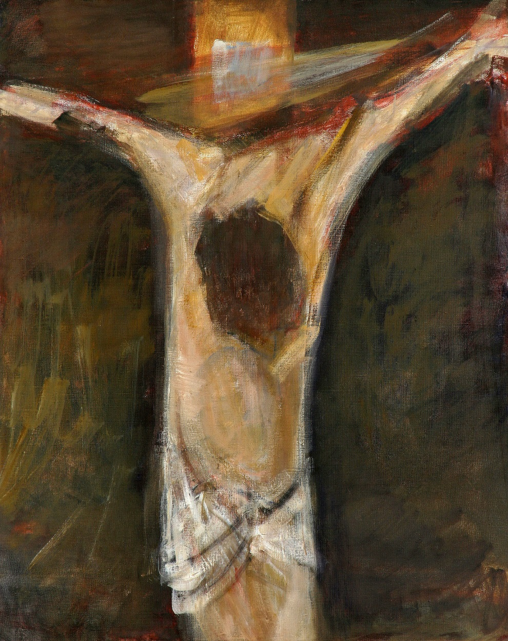
Stations of the Cross
for
Atonement and Healing

Diocese of Scranton

Stations of the Cross for Atonement and Healing © Diocese of Scranton, 2019.
Artwork from the Cathedral Church of the Holy Cross in Sisak, Croatia. © Zatletic. www.dreamstime.com. Used with permission.
Scripture quotations from The New American Bible. Washington, DC. United States Conference of Catholic Bishops, 2002.
Hymn text: Stabat Mater dolorosa by Jacopone da Todi, 1230-1306; translated by Edward Caswall, 1814-1878. Public domain.
L/. = Leader R/. = Response by All

Introduction

L/. In the name of the Father, and of the Son, and of
the Holy Spirit.
R/. Amen.

L/. We, the Church, acknowledge this present moment as a one of the darkest in our history. As members of Christ’s body on earth, we bear the marks of shame, anger, sorrow, and guilt as a result of the sexual misconduct of clergy and cover-up by Church leaders. We seek to join our woundedness, especially the pain and anguish of those who have been abused, to the sufferings of Jesus. May our prayers be heard by our merciful God, whose Son was pierced for our offenses, and through whom we receive reconciliation.

R/. Heavenly Father, your Son, accepted the cross and walked this path to Calvary for both saint and sinner alike. We humbly pray that by walking these fourteen stations with Jesus, we may attune our hearts and minds to those have been abused so that they may now have healing through our atonement, accountability and reparation. May we pray and work together so that the Church may again be a sign of hope in world and a safe refuge for all. We ask this in his name. Amen.

At the cross her station keeping,
Stood the mournful Mother weeping,
Close to Jesus to the last.

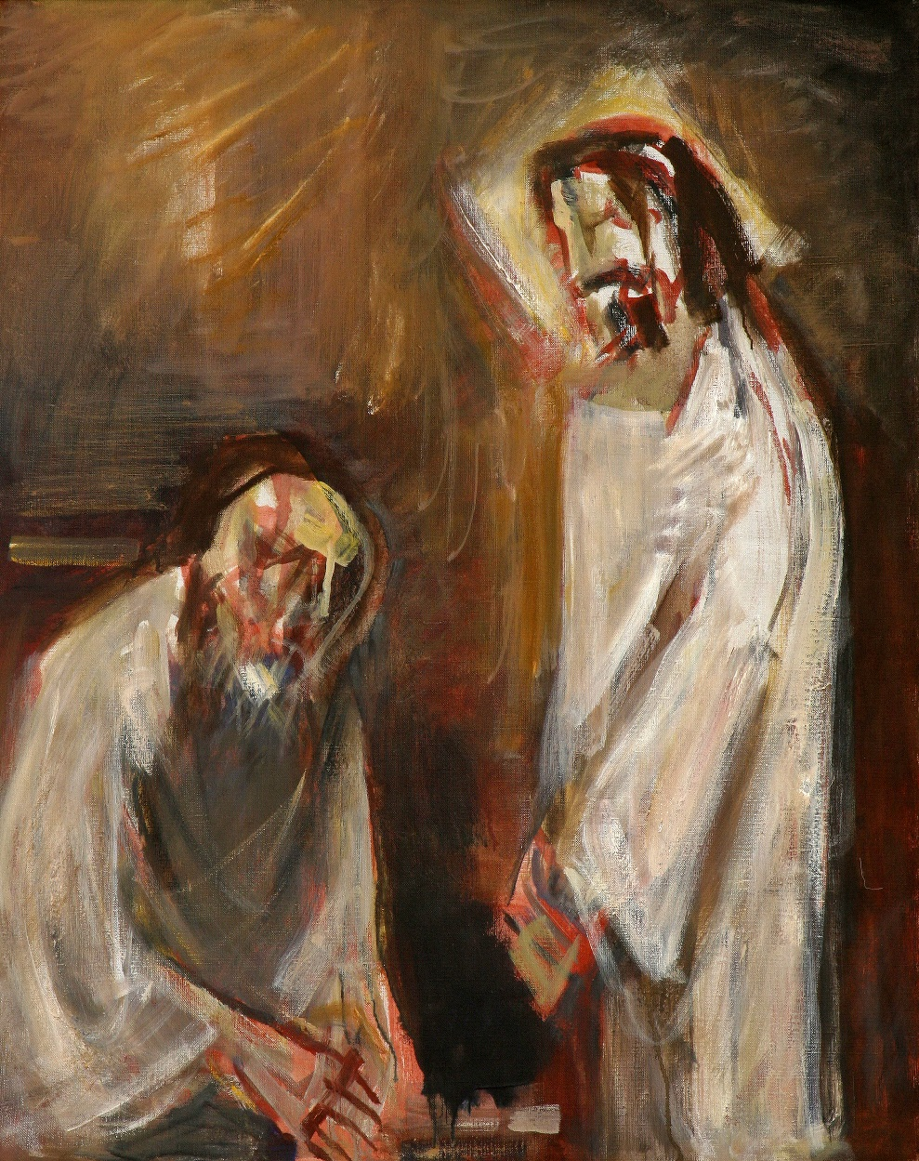

First Station: Jesus Is Condemned to Death

L/. We adore you O Christ, and we praise you.
R/. Because by your holy cross, you have redeemed the world.

L/. Pilate said to the crowd, “Then what shall I do with Jesus called Messiah?’ They all said, “Let him be crucified!” When Pilate saw that he was not succeeding at all, but that a riot was breaking out instead, he took water and washed his hands in the sight of the crowd, saying, “I am innocent of this man’s blood. Then he released Barabbas to them, but after he had Jesus scourged, he handed him over to be crucified.” (Matthew 27:22, 24, 26)

Innocent, alone and silent, Jesus stands before Pilate and the crowd. Although Pilate attempts to set Jesus free, the pressure to yield to the people’s demands grows, and he washes his hands of the situation. We, too, as the Church have washed our hands of the many situations of sexual abuse, seeking to protect ourselves instead of victims. May we always be vigilant in the protection of children entrusted to our care.

R/. Lord, Jesus Christ, though you had done no wrong, you accepted death for our salvation. Hear our prayers that clergy, parents, teachers, catechists, coaches, youth ministers and mentors may not wash their hands of instances of abuse, but be vigilant in recognizing and reporting such behavior. May we embrace our mission to protect the innocence of children, and to offer compassion to those who have suffered abuse. In your holy name, we pray.

Through her heart, his sorrow sharing,
All his bitter anguish bearing,
Now at length the sword has passed.

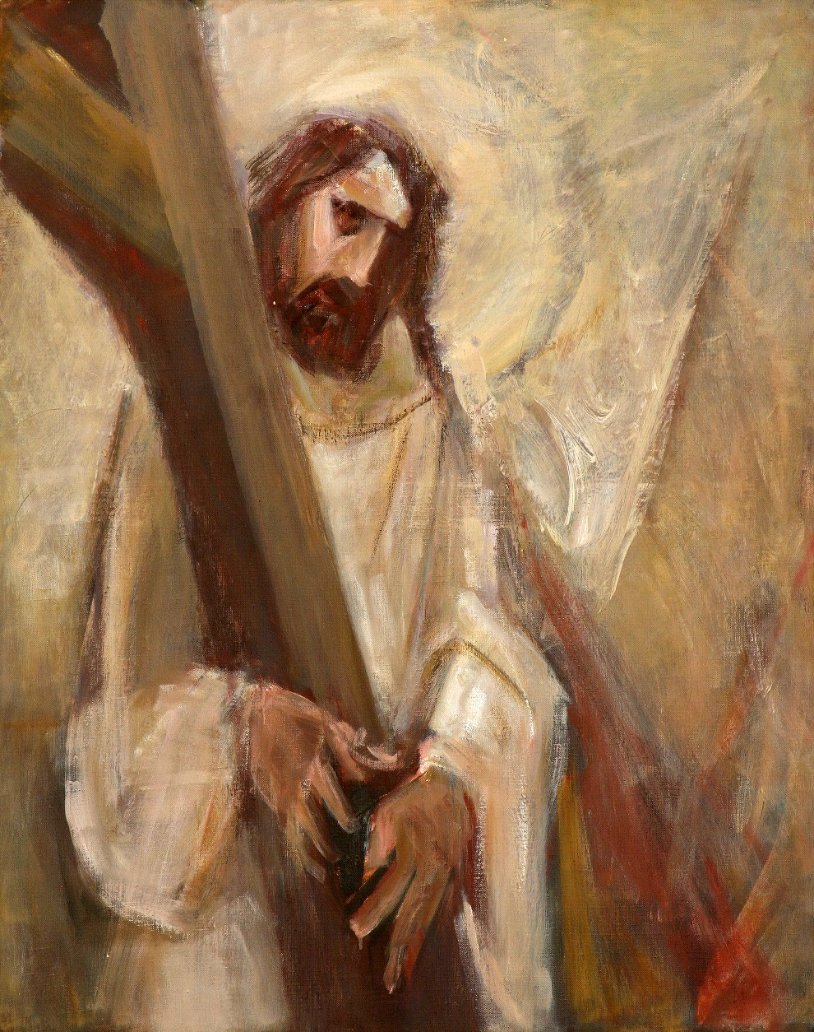

Second Station: Jesus Accepts His Cross

L/. We adore you O Christ, and we praise you.
R/. Because by your holy cross, you have redeemed the world.

L/. So they took Jesus, and carrying the cross himself he went out to what is called the Place of the Skull, in Hebrew, Golgotha. (John 19:17)

Recall the words Jesus said to his disciples, “Whoever wishes to come after me must deny himself, take up his cross, and follow me.” In accepting his own cross, Jesus bears the weight of our iniquities, for he is the Lamb of God who takes away the sins of the world. We, also, are called to bear the cross of suffering for those abused in the Church and for all of those whose faith has been shaken over this crisis.

R/. Lord, Jesus Christ, you willingly accepted the cross, an instrument of torture and death, and brought forth from it life in the Resurrection. May we, the Church, accept the cross of our shameful past and bear the weight of responsibility and guilt for these sins. Although we cannot erase the memories of these actions, help us to learn from our mistakes. In your holy name, we pray.

O how sad and sore distressed,
Was that Mother highly blest
Of the sole begotten One!

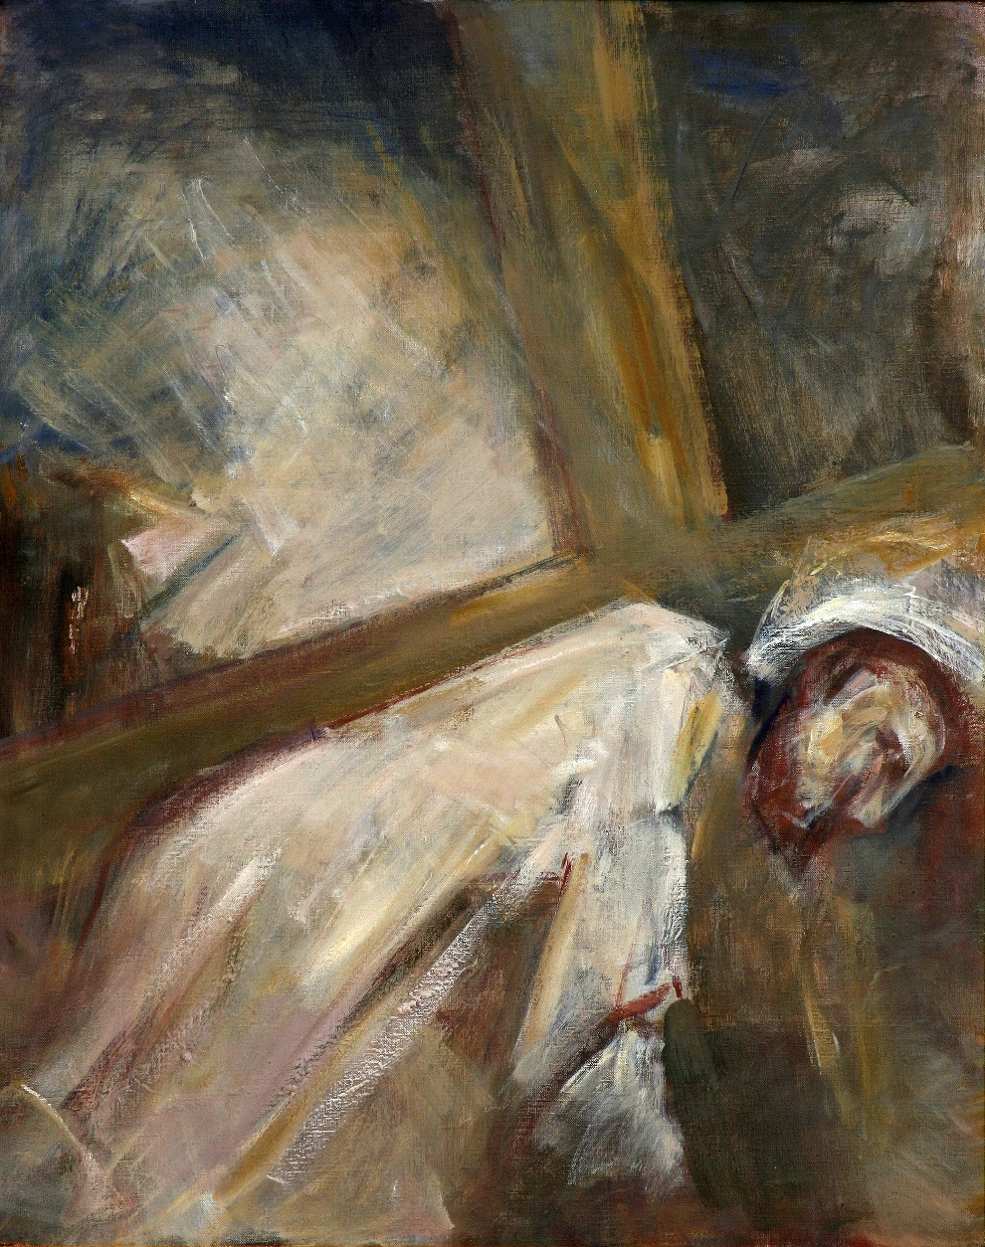
Third Station: Jesus Falls the First Time

L/. We adore you O Christ, and we praise you.
R/. Because by your holy cross, you have redeemed the world.

L/. Yet it was our pain that he bore, our sufferings that he endured. We thought of him as stricken, struck down by God and afflicted…” (Isaiah 53:4-5)

The weight of the cross being too unbearable, Jesus falls underneath its weight. The Lord of all creation, now appears frail and struggles against the harsh treatment of the soldiers and the crowd. In this first fall, we recall the victims of sexual abuse in our own diocese, and how the sinfulness of clergy and mishandling by Church leaders adds to the weight of the cross. Knowing that those who were once entrusted with Christ’s mission to shepherd souls have instead betrayed the faithful, we ask for forgiveness from those victims--perhaps some of them we know, or perhaps some of them are here among us now.

R/. Lord, Jesus Christ, by your own sorrowful passion, you know the anguish of all who suffer. Hear our prayers for those victims of sexual abuse in our diocese and relieve them of the emotional burdens they have carried. We pray that they may learn to forgive the wrongs done to them by the Church so that healing may abound. May we never forget their suffering in our efforts to rebuild trust in the Church. In your holy name, we pray.

Christ above in torment hangs,
She beneath beholds the pangs
Of her dying, glorious Son.

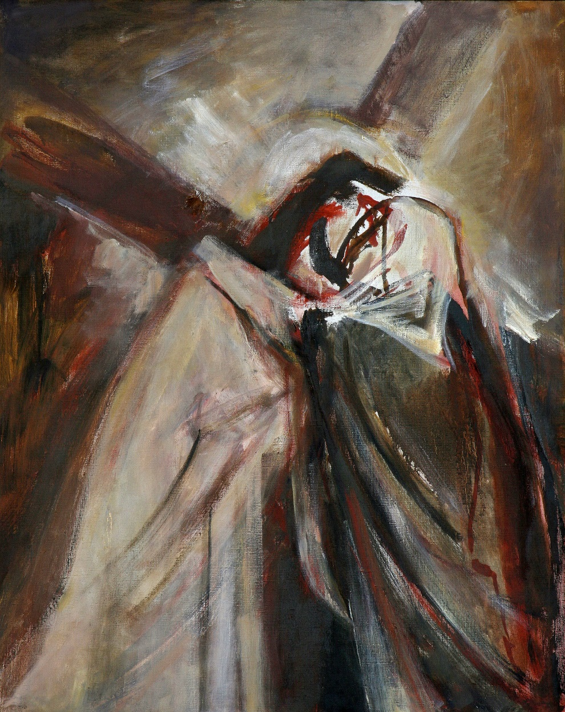

Fourth Station: Jesus Meets His Mother

L/. We adore you O Christ, and we praise you.
R/. Because by your holy cross, you have redeemed the world.

L/. Simeon blessed Jesus, Mary and Joseph and said to Mary his mother, “Behold, this child is destined for the fall and rise of many in Israel, and to be a sign that will be contradicted, and you yourself a sword will pierce so that the thoughts of many hearts may be revealed. (Luke 2:34-35)

The scene is profound: the mother, Mary, embracing her son, Jesus, for the last time before he is brutally executed. The pain of a mother losing a child is unbearable, and in this encounter we can also see into the lives of the parents of those abused by clergy. A mother’s faith and trust in humanity is betrayed, and the innocence of childhood robbed. The Blessed Virgin Mary, Our Lady of Sorrows, knows the helplessness of parents who had nowhere to turn and no one to listen after these acts of abuse.

R/. Lord, Jesus Christ, your mother, Mary, was chosen among all women to become the new Eve. As we reflect upon her Immaculate Heart pierced with sorrow, we offer prayers for all parents of abuse victims in the Church. Although they may feel helpless to ease their children’s burden, grant parents the grace to be present, to listen, and to support their children in whatever care they need to overcome such violations of the human person. In your holy name, we pray.

Is there one who would not weep,
Whelmed in miseries so deep,
Christ’s dear Mother to behold?

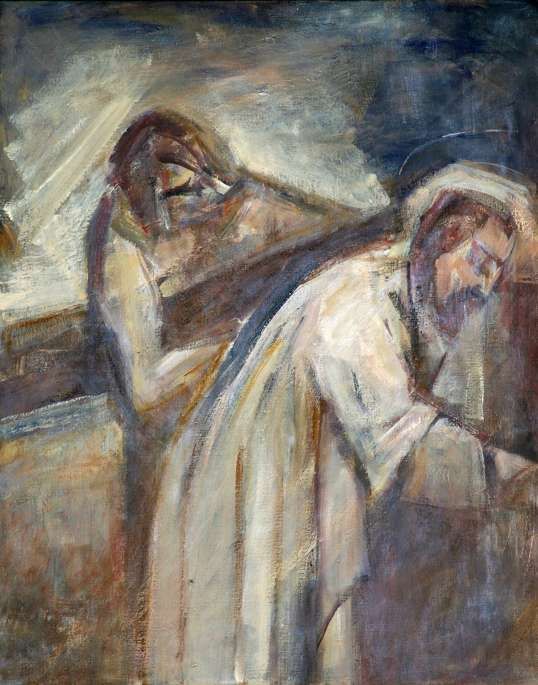

Fifth Station: Simon Helps Carry Jesus’ Cross

L/. We adore you O Christ, and we praise you.
R/. Because by your holy cross, you have redeemed the world.

L/. They pressed into service a passer-by, Simon, a Cyrenian, who was coming in from the country to carry his cross. (Mark 15:21)

Fearing that Jesus should die before reaching the place of crucifixion, the soldiers enlisted Simon, an innocent bystander, to shoulder the cross. Perhaps Simon knew nothing about this Jesus of Nazareth, but helped him nonetheless in the deepest hour of his suffering. So many social workers, counselors, therapists, psychologists and psychiatrists have helped carry the crosses of those burdened with the devastating effects of sexual abuse. These professionals have seen first-hand the bitter anguish in the faces of those whose trust in the Church has been shattered.

R/. Lord, Jesus Christ, through your passion and death, you taught us that there is no greater love than to lay down your life for a friend. We thank you for the gifts of consolation and understanding shown by experts in the mental and behavior health fields. May the work they do in assisting victims of abuse lead to personal healing, forgiveness for the wrongs done by the Church, and renewal in their sense of dignity and purpose. In your holy name, we pray.

Can the human heart refrain
From partaking in her pain,
In that Mother’s pain untold?

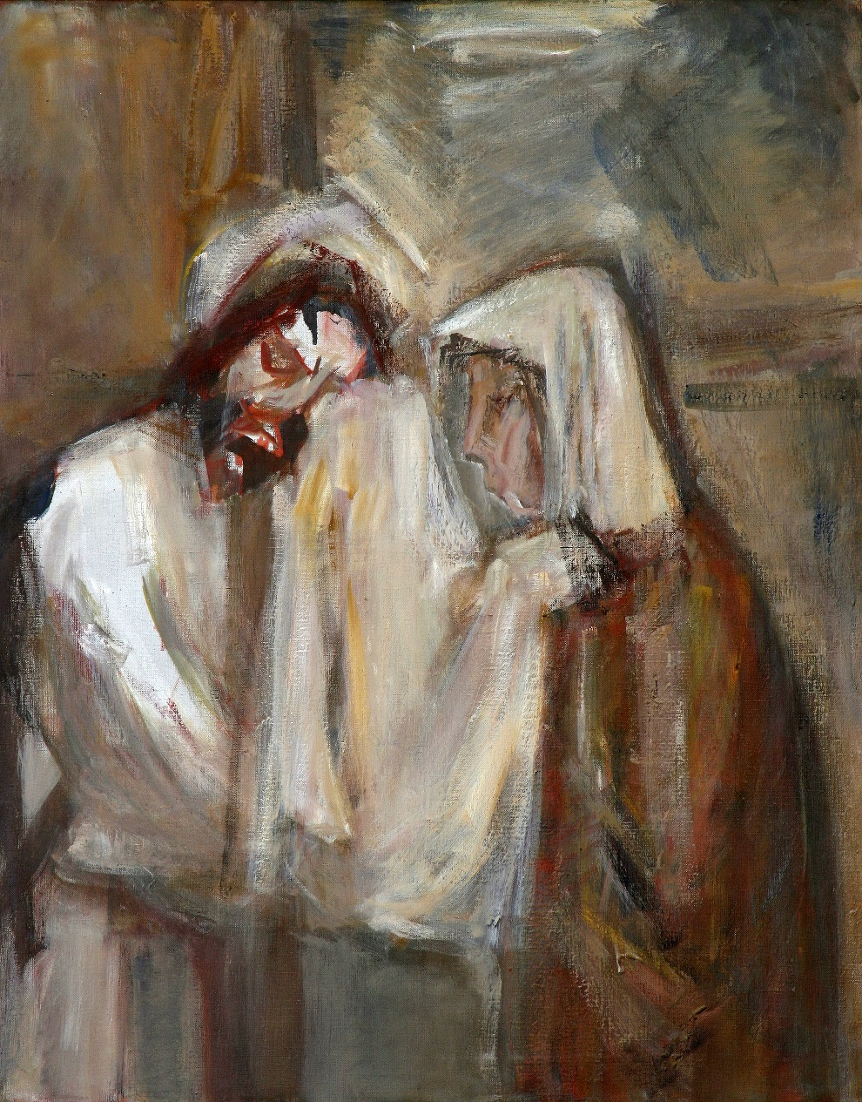
Sixth Station: Veronica Wipes the Face of Jesus

L/. We adore you O Christ, and we praise you.
R/. Because by your holy cross, you have redeemed the world.

L/. “For I was hungry and you gave me food, a stranger and you welcomed me, naked and you clothed me, ill and you cared for me, in prison and you visited me…Amen, I say to you, whatever you did for one of these least brothers of mine, you did for me.” (Matthew 25:35, 40)

Veronica, in wiping the bloodied face of Jesus with her veil, shows what a difference a gesture of kindness can make. In response, Jesus leaves an imprint of his face upon her veil. Despite the recent revelations of sexual misconduct in the Church, reforms for well over a decade have been working, thanks to the efforts of the laity. Entrusted with the incredible responsibility of safe environment training of clergy, parish staff, and volunteers, the lay faithful have made a huge difference in eradicating sexual abuse in the Church.

R/. Lord, Jesus Christ, you taught us that unless you become like a little child, you will never enter the kingdom of heaven. Reborn as your children through waters of baptism, we depend on your grace and mercy to sustain our lives. Watch over and guide all of those who promote and train volunteers in safe environment practices so that no one is led astray or victimized by abuse. May we each do our part to ensure that the Church is a safe place for all children to learn, grow, and rejoice in your love. In your holy name, we pray.

Bruised, derided, cursed, defiled,
She beheld her tender Child,
All with bloody scourges rent.

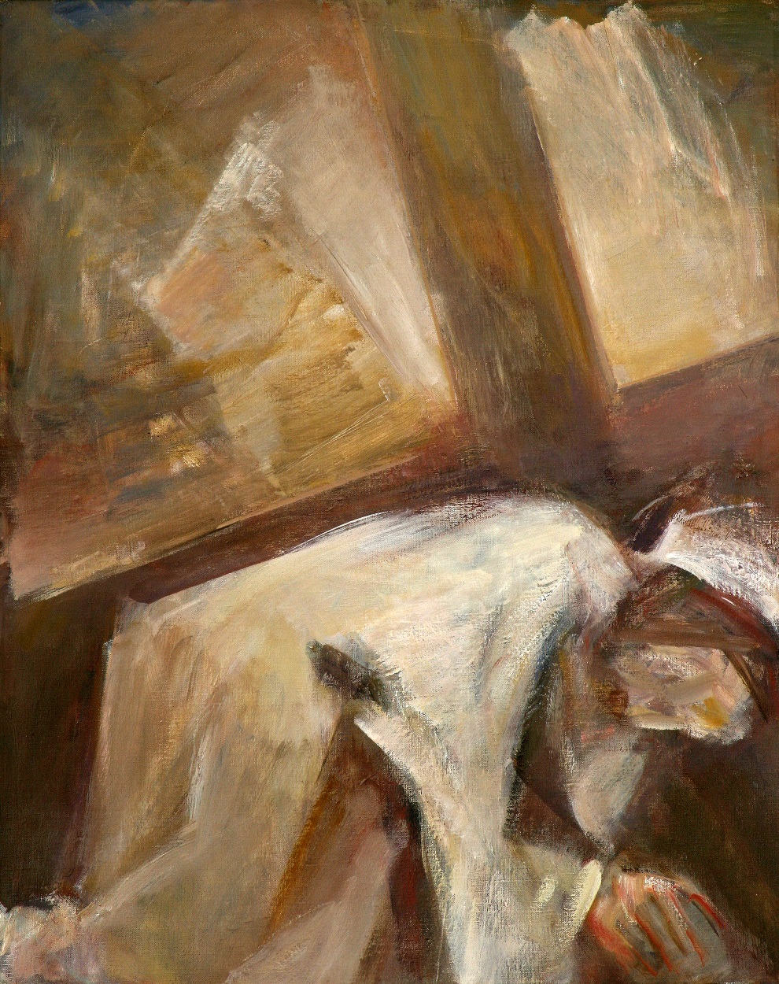

Seventh Station: Jesus Falls the Second Time

L/. We adore you O Christ, and we praise you.
R/. Because by your holy cross, you have redeemed the world.

L/. Though harshly treated, he submitted and did not open his mouth; Like a lamb lead to slaughter or a sheep silent before shearers, he did not open his mouth. (Isaiah 53:7)

As Jesus’ journey to Calvary continues, the path seems longer and longer. The pain becomes more intense, the weight of the cross unbearable, and Jesus falls again under its weight. Although the recent exposition of sexual misconduct and cover-up in the Church began in the state of Pennsylvania, dioceses and religious orders throughout our country are gradually becoming more transparent about past cases of abuse. The weight of past sins in the Church is growing, adding to the burden of Christ’s cross. People are angry as they realize the scope of this crisis.

R/. Lord, Jesus Christ, you warned us about the seriousness of causing any little ones to stumble. In recalling your second fall on the way to the cross, we pray for all victims of clerical abuse in our country. People’s lives have been shatter as a result of such actions and we, the faithful, are also wounded. Heal our pain, and let us strive to make amends so that the Church in America may once again be a beacon of hope for all people. In your holy name, we pray.

For the sins of his own nation
Saw him hang in desolation
Till his spirit forth he sent.

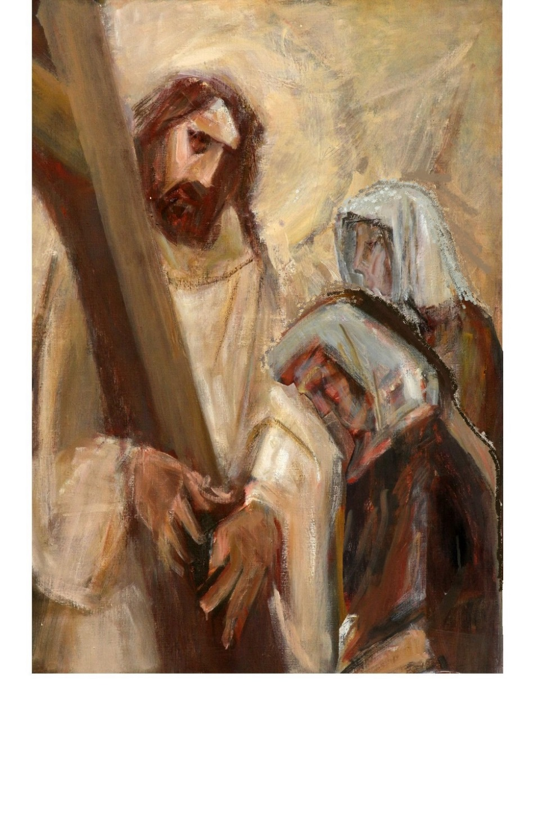
Eighth Station: Jesus Meets the Women of Jerusalem

L/. We adore you O Christ, and we praise you.
R/. Because by your holy cross, you have redeemed the world.

L/. A large crowd of people followed Jesus, including many women who mourned and lamented him. Jesus turned to them and said, “Daughters of Jerusalem, do not weep for me; weep instead for yourselves and for your children, for indeed, the days are coming when people will say, ‘Blessed are the barren, the wombs that never bore.’” (Luke 23: 27-31)

Although in great agony on the path towards his death, Jesus instructs the women of Jerusalem not to weep for him. Instead, he warns them about the horrible future in store with the fall of Jerusalem, a time of such distress that the barren will be considered blessed because they do not bring children into a world of destruction and abandonment. The reality today is that parents are concerned about their children’s involvement in the Church because of the abuse crisis. Although many measures have been established to prevent such abuse, there are those who still say, “I’m afraid to bring children into such a dangerous world as this.”

R/. Lord, Jesus Christ, you instructed your disciples to let the children come to you and do not hinder them. Through the sins of clergy and neglect by Church leaders, countless numbers of children have been harmed and prevented from experiencing your loving mercy and compassion. We pray for the protection of all youth in the Church. Help us to strive eagerly to ensure the well-being and safety of all children entrusted to our care. In your holy name, we pray.

O thou Mother! Font of love,
Touch my spirit from above,
Make my heart with thine accord.

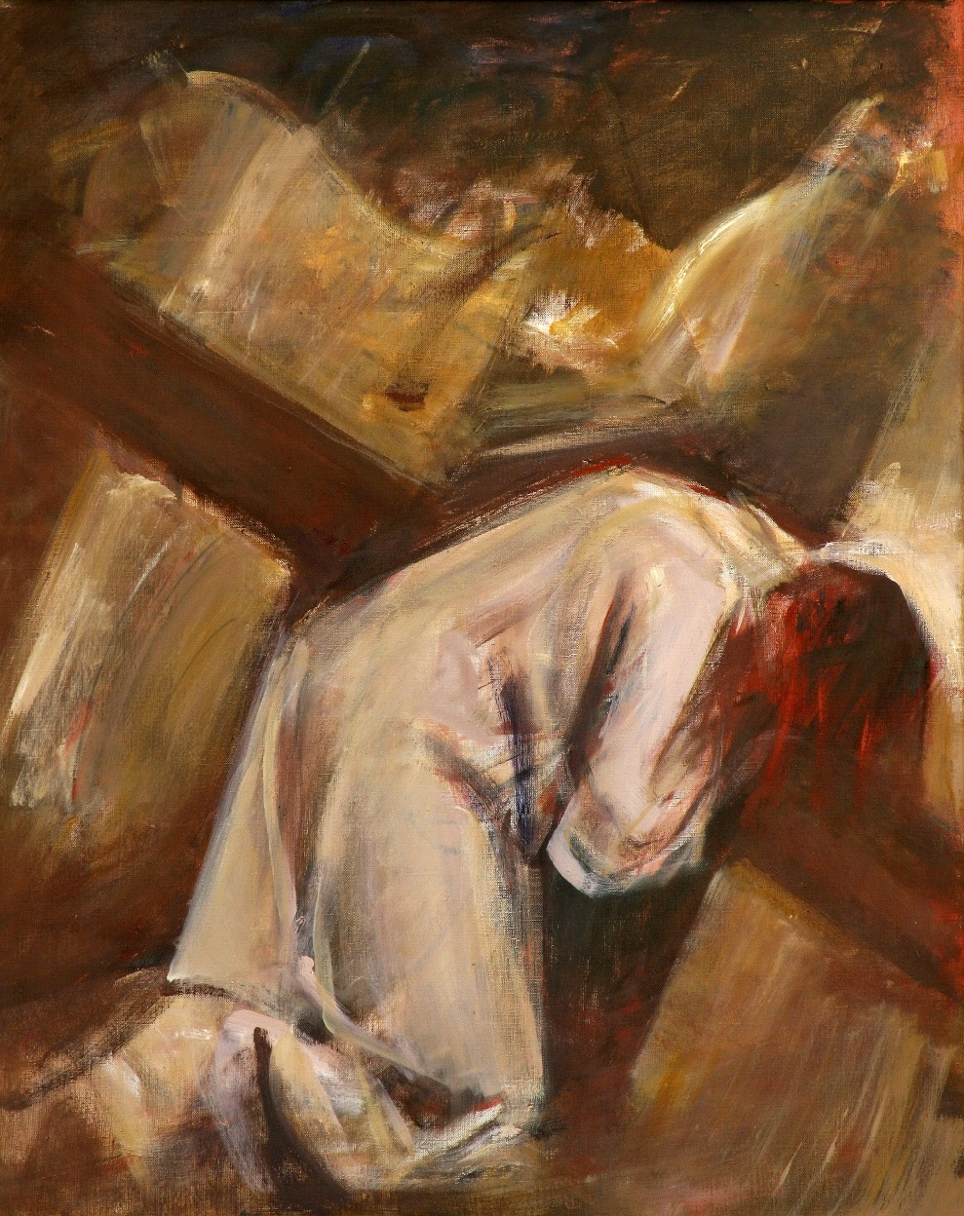

Ninth Station: Jesus Falls the Third Time

L/. We adore you O Christ, and we praise you.
R/. Because by your holy cross, you have redeemed the world.

L/. Because of his anguish he shall see the light; because of his knowledge he shall be content; My servant, the just one, shall justify the many, their iniquity he shall bear. (Isaiah 53: 11)

Just before reaching the place of his crucifixion, Jesus falls a third time. The rough wood and weight of the cross have continuously dug into his beaten flesh, and this fall is the most difficult from which to recover. By now, it has become obvious that clerical abuse in the Church is more than just isolated cases, but a global crisis. Church leaders throughout the world are now coming forward with thousands of names of individuals credibly accused of sexual misconduct. The harsh reality of these mounting cases of sin causes our Lord to fall a third time.

R/. Lord, Jesus Christ, you are the Lamb of God who bears our sins. This global crisis of abuse has brought shame upon all members of your Mystical Body, the Church. We join the cries of all who have suffered abuse in the world to your cries of agony in your passion. Heal their pain, their years of mental anguish, and give us the firm resolve to build trust in the Church again. In your holy name, we pray.

Make me feel as thou hast felt;
Make my soul to glow and melt
With the love of Christ, my Lord.

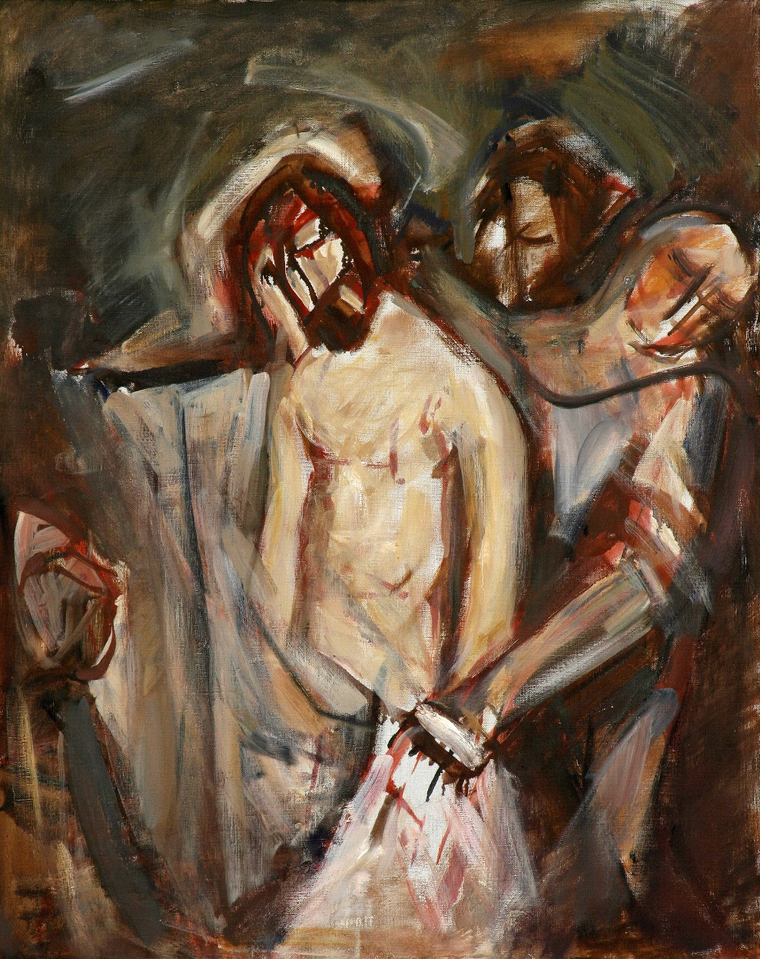

Tenth Station: Jesus Is Stripped of His Garments

L/. We adore you O Christ, and we praise you.
R/. Because by your holy cross, you have redeemed the world.

L/. The soldiers took his clothes and divided them into four shares, a share for each soldier. The also took his tunic, but the tunic was seamless, woven in one piece from the top down. So they said to one another, “Let’s not tear it, but cast lots for it to see whose it will be,” in order that the passage of scripture might be fulfilled that says, “They divided my garments among them, and for my vesture they cast lots.” (John 19:23)

Arriving at the place where he was to be crucified, the soldiers stripped Jesus of his garments. The fabric that adhered to his wounds from the scourging is now ripped away, opening his wounds once more. Jesus stands humiliated and bleeding before the crowd. Likewise, each person sexually abused in the Church been stripped of his or her human dignity. Feeling ashamed, most victims have hid their haunting secrets of abuse until now, and many more still remain hidden.

R/. Lord, Jesus Christ, you allowed yourself to be beaten, abused, and stripped on account of our sinfulness. Hear us as we call upon you. Bestow your grace upon those victims who still hold the dark secrets of abuse in their hearts and minds. Give them courage to come forward so that through their testimony, no one else in the Church may be harmed, and that your peace may prevail in their hearts. In your holy name, we pray.

Holy Mother, pierce me through,
In my heart each wound renew
Of my Savior crucified.

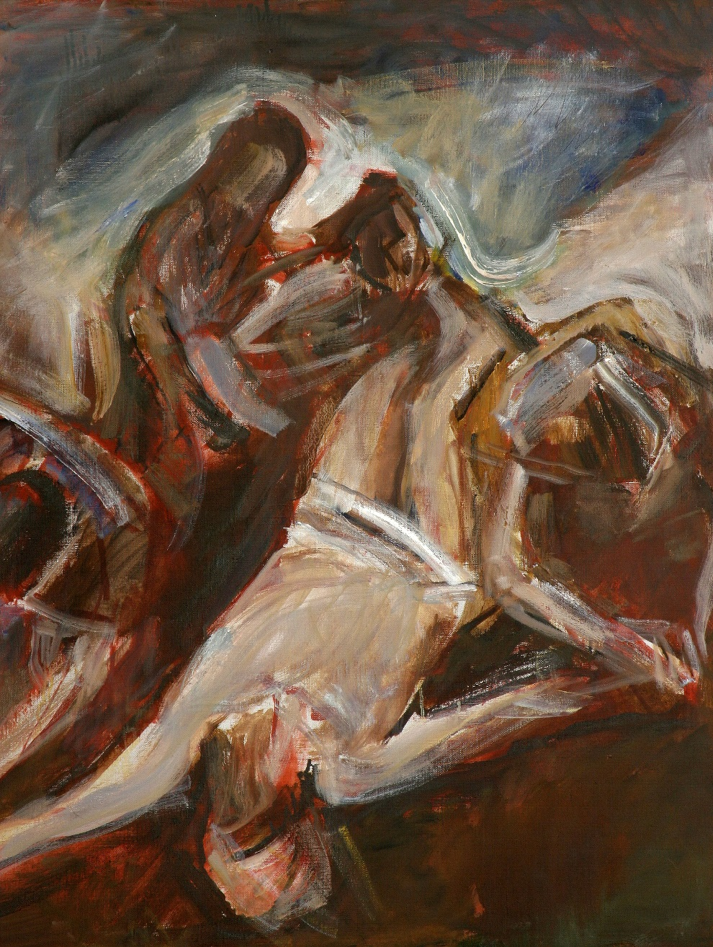

Eleventh Station: Jesus Is Nailed to the Cross

L/. We adore you O Christ, and we praise you.
R/. Because by your holy cross, you have redeemed the world.

L/. When they came to the place called the Skull, the crucified him and the other criminals there, one on his right, the other on his left. (Luke 23:33)

Jesus, already tortured through the scourging, the crowning with thorns, and the carrying of the cross, now endures being nailed to the cross. A shooting pain goes through his arms and legs straight to his head as the spikes are driven in. Out of all the suffering born by victims of sexual abuse, perhaps none greater is mental illness. Long after the abuse has happened, the torment from such heinous acts lives on in their minds, as if they too were nailed to a cross they cannot escape.

R/. Lord, Jesus Christ, you stretched out your arms on the cross for our salvation. We join to your agony on the cross the suffering of all those with mental illness as a result of abuse in the Church. May they receive healing through your grace and the support that they need through our efforts. May we never forget that such criminal acts against children can have a devastating effect on their entire life. In your holy name, we pray.

Let me share with thee his pain,
Who for all my sins was slain,
Who for me in torment died.

Twelfth Station: Jesus Dies on the Cross

L/. We adore you O Christ, and we praise you.
R/. Because by your holy cross, you have redeemed the world.

L/. It was now about noon and darkness came over the whole land until three in the afternoon because of an eclipse of the sun. Then the veil of the temple was torn down the middle. Jesus cried out in a loud voice, “Father, into your hands I commend my spirit”; and when he had said this he breathed his last. (Luke 23: 44-46)

[all kneel for a brief moment of silence]

L/. The scene looks like something out of a horror movie: sudden darkness because of eclipse, a mighty wind that tears the veil of the temple, and an innocent man dies a horrible death. God has died in the flesh as a result of human sinfulness. As we reflect upon the horror of Jesus’ own death, we consider those who have committed suicide as a result of sexual abuse at the hands of clergy—that the heinous sin of another could overtake their hearts and minds, leading them to choose death.

R/. Lord, Jesus Christ, by your own death on the cross you have sanctified the death of all believers. As we meditate on your passion, we pray for those who could no longer bear the trauma of sexual abuse by those they trusted in the Church. May you look mercifully upon their anguish and welcome them to your kingdom where there is no more wailing, suffering, or pain. In your holy name, we pray.

Let me mingle tears with thee,
Mourning him who mourned for me,
All the days that I may live.

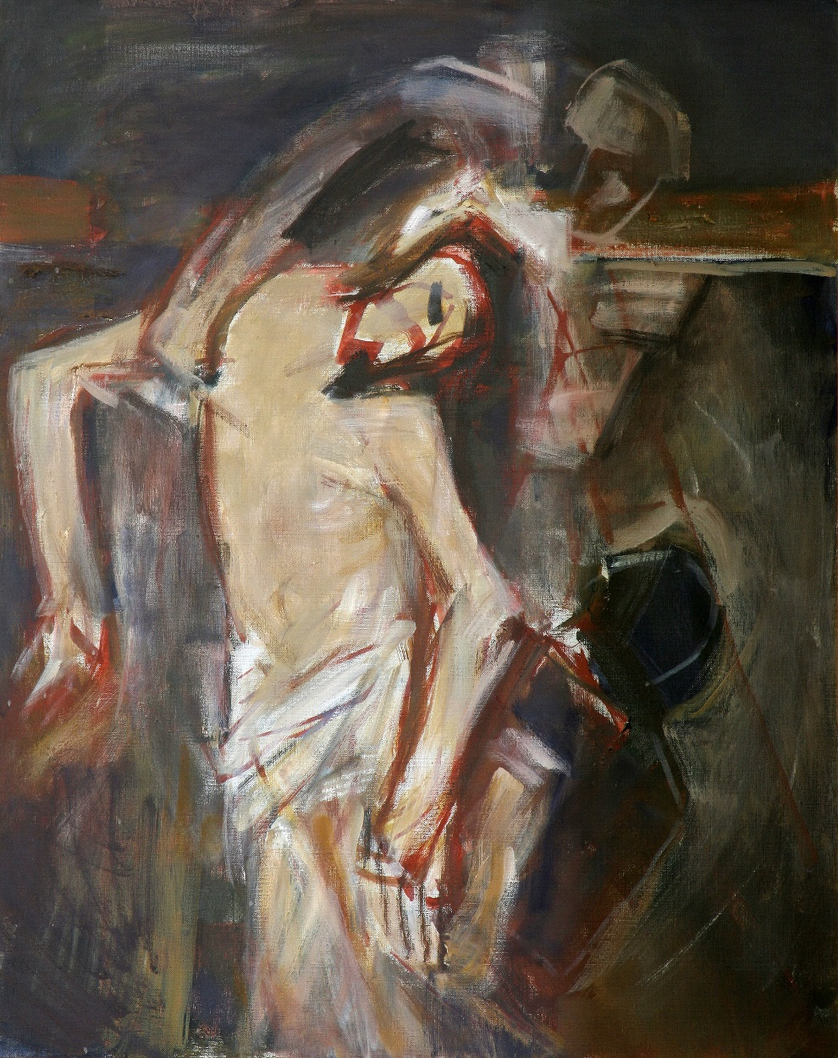

Thirteenth Station:
Jesus Is Taken Down from the Cross

L/. We adore you O Christ, and we praise you.
R/. Because by your holy cross, you have redeemed the world.

L/. Now there was a virtuous and righteous man named Joseph who…came from the Jewish town of Arimathea and was awaiting the kingdom of God. He went to Pilate and asked for the body of Jesus. After he had taken the body down, he wrapped it in a linen cloth… (Luke 23:50-55)

The crowd has gone, and no one remains at the scene of the crucifixion but Joseph of Arimathea, some women, and Mary, the mother of Jesus. Holding her son again in her arms, she weeps as only a mother can weep over the loss of a child. She is now alone, without a husband, without a son. Jesus has entrusted the Church to his mother, and his mother to the Church. It is her intercession that our Holy Father, all bishops, priests and deacons seek, especially during this time of crisis in the Church.

R/. Holy Mary, Mother of God, you embraced God’s plan for your life including its deepest sorrows. As the Mother of the Church which now suffers so greatly these sins against its young ones, we implore your intercession for our Holy Father, and for all faithful bishops, priests and deacons. May the good work they do help alleviate the suffering of abuse victims, and may they enable the gifts of all the baptized in preventing abuse. Holy Mary, pray for us.

By the cross with thee to stay;
There with thee to weep and pray,
All I ask of thee to give.

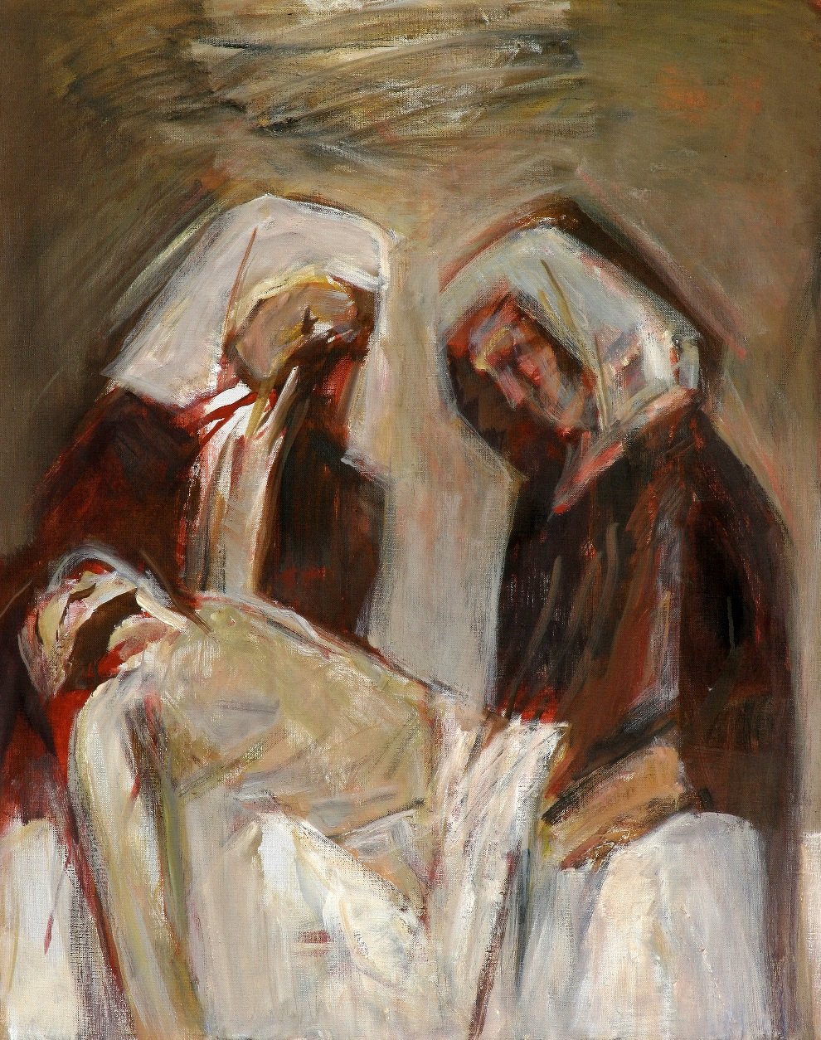

Fourteenth Station: Jesus Is Laid in the Tomb

L/. We adore you O Christ, and we praise you.
R/. Because by your holy cross, you have redeemed the world.

L/. Now in the place where he had been crucified there was a garden, and in the garden a new tomb, in which no one had yet been buried. So they laid Jesus there because of the Jewish preparation day; for the tomb was close by. (John 20:41-42)

As the stone is rolled over the entrance to Jesus’ tomb, it is as if the door to hope was being closed. Those who had placed their deepest faith and trust in Jesus as the promised Messiah were now left devastated, hopeless and uncertain. Those who have left the Church because of the sexual abuse crisis share the same emotions. They are devastated that men of God could do such horrible things; they have lost hope in the Church that would hide this kind of behavior; their lives now follow a path of uncertainty as to what to believe.

R/. Lord, Jesus Christ, through your own rest in the tomb, you showed us that death is not the end, but that life can come forth anew. We pray for our brothers and sisters who have left the Church because of the abuse crisis. May they still seek you with a sincere heart. Strengthen us to strive eagerly to rebuild their faith and trust through our acts of charity and by working together in solidarity to create a safe environment for everyone in the Church. In your holy name, we pray.

Virgin of all Virgins blest!
Listen to my fond request:
Let me share thy grief divine.
Concluding Prayer

ALL: Heavenly Father,
through your Son’s passion, death and resurrection,
you bore the sins of the world
and brought new life to all.
In walking these fourteen steps,
we offer to you the suffering
of all of our brothers and sisters in the Church
who have been victims of abuse.
As members of Christ’s body,
we too bear the mark
of shame, sorrow and anger
because of such appalling acts by clergy.
The wounds of your Son,
once a sign of shame and disgrace,
became the source of our salvation.
Turn then, we pray,
these wounds of abuse and sorrow
into signs of hope and renewal.
Relying on your grace,
may we all work actively
to make atonement for these sins against your love, and to foster healing for those abused
and for all members of the Church.
We pray this through Christ our Lord.
Amen.

L/. In the name of the Father, and of the Son,
and of the Holy Spirit.
R/. Amen.

