Notes for Pastors/Sacramental Ministers for the Conferral of Confirmation
From The Order of Confirmation (2016)
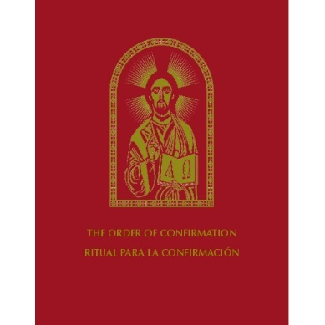
Ritual Book
Order of Confirmation/Ritual para la Confirmación, United States Conference of Catholic Bishops, Washington D.C., 2016—the bilingual edition can be ordered through the USCCB website store [www.store.usccb.org] and searching for “Order of Confirmation.” The cost is $49.95.

Involves the Entire Parish
“The whole People of God, represented by the families and friends of the candidates for Confirmation and by members of the local community, will be invited to take part in such a celebration and will endeavor to express their faith by means of the fruits the Holy Spirit has produced in them.” (The Order of Confirmation #4)

The Bishop Is the Ordinary Minister of Confirmation
The Bishop is the ordinary minister of Confirmation. If necessary, the Bishop can grant the faculty to priests, specifically to pastors of the places where Confirmation is conferred. (The Order of Confirmation #7-8)

Recording the Confirmation
“The names of those confirmed, with mention made of the minister, the parents, and sponsors, and the place and date of the conferral of Confirmation are to be recorded…in a register to be kept in the parish archives. The pastor must inform the pastor of the place of Baptism about the conferral of Confirmation, so that a notation is made in the baptismal register, according to the norm of the law.” (The Order of Confirmation #14)

Called by Name
“The candidates for Confirmation are presented by the Pastor, or another Priest, or by a Deacon, or even by a catechist, in accordance with the custom of each region, in this way: if possible, each of those to be confirmed is called by name and individually approaches the sanctuary…If there are very many candidates, they are not called by name; but they are assigned to a suitable place before the Bishop.” (The Order of Confirmation #21) Since the Pastor will be celebrating the Confirmation, it would be appropriate to have the DRE or Coordinator for Confirmation present the candidates. In parishes that will have the Sacramental Minister celebrate the Confirmation, the candidates should be presented by the Parish Life Coordinator.

Mention the Sacramental Connection to the Bishop in the Homily
“When Confirmation is conferred by an extraordinary minister…it is fitting for him to mention in the homily that the Bishop is the ordinary minister of the Sacrament and to explain the reason why even Priests receive the faculty to confirm from the law or by an indult of the Apostolic See.” (The Order of Confirmation #18)

Approach THOSE TO BE CONFIRMED for the Anointing
“The sacred Chrism is brought by the Deacon to the Bishop. Each of those to be confirmed goes to the Bishop; or, if appropriate, the Bishop goes to each of those to be confirmed.”
CREED & UNIVERSAL PRAYER
Since a Profession of Faith has already been made, the Creed is omitted. There are sample intercessions for the Universal Prayer in the Order of Confirmation. (#30-31)

EUCHARISTIC PRAYER
The Order of Confirmation contains the proper inserts for Eucharistic Prayers I, II and III. Please see #58 in the ritual book.

THE BLESSING
The Order of Confirmation provides a Solemn Blessing and a Prayer over the People before the Dismissal (#33). Before using the Solemn Blessing, consider rehearsing the triple “Amen” response with those to be confirmed.

LITURGICAL NOTES FOR CONFIRMATION ON PENTECOST
- You must use the readings and prayer texts for the Solemnity of Pentecost (either for the Vigil or Day). You would not use the readings or prayers for the Ritual Mass of Confirmation.
- The Sequence proper to Pentecost is sung (preferable) or said after the Second Reading but before the Gospel Acclamation.
- Double-Alleluia dismissal is sung or said

