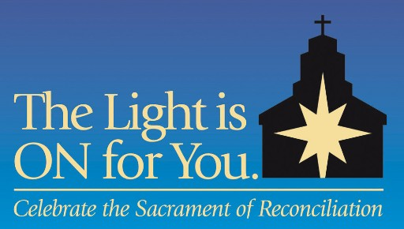

SAMPLE INTERCESSIONS FOR THE UNIVERSAL PRAYER

General Intercessions:
- That Catholics in our Diocese will heed the Lord’s Lenten call to repentance and choose to participate in The Light is On For You celebration of reconciliation, to receive forgiveness in the Sacrament of Penance. We pray to the Lord…
- That Catholics who have been wounded by the Church or fallen away from regular practice of their faith will feel welcomed and return to the Sacrament of Reconciliation during The Light is On For You process this Lent, in order to receive the Lord’s loving mercy and begin again. We pray to the Lord…

Intercessions to be included in the Universal Prayer during each Lenten Sunday:
- March 10: That Catholics who have been away from the practice of the Sacrament of Confession will participate in the Diocesan celebration of Reconciliation, The Light is On For You, and come to be reconciled with God during this season of Lent. We pray to the Lord…
- March 17: That all us, aware of the temptation to sin, will come and receive Jesus’ loving mercy during the special Diocesan celebration of reconciliation, The Light Is On For You, Monday nights during Lent. We pray to the Lord…
- March 24: That all of us will heed God the Father’s command to listen to his Son, and act on his call to repentance by making a good confession during the Diocesan celebration of Reconciliation, The Light is On For You, Monday nights during Lent. We pray to the Lord…
- March 31: That each of us will notice our thirst for God, and welcome the graces offered to us during the Diocesan celebration of Reconciliation, The Light Is On For You, Monday nights during Lent. We pray to the Lord…
- April 7: That each of us, desiring to live the truth and come to the light, will make a good confession during the Diocesan celebration of Reconciliation, The Light is On For You, Monday nights during Lent. We pray to the Lord…
- April 14: That each of us will experience, in Jesus, God’s power to set us free and to give us a new life in service to the Gospel, as we share in the Paschal Triduum during this Holy Week. We pray to the Lord…

