Altar Server Training—Leader’s Guide

Overview of the Ministry

Role of the Altar Server
The role of the altar server is to assist the priest and/or deacon during Mass on Sundays or other important days in the life of the Church. It also means helping with the setup and preparations immediately before Mass and staying briefly to assist with any cleanup or tasks afterwards.

Serving God and the Church
By becoming an altar server you are also serving God and serving the prayer of the members of the Church called the Body of Christ. At the Last Supper, Jesus gave us his Body and Blood under the appearance of bread and wine. On Good Friday, he gave his very life on cross for our sins. On Easter Sunday, Jesus rose from the dead, and from that time on Christians have gathered on Sunday to remember his death and resurrection.

Your participation as an altar server helps the prayer of the gathered faithful in several ways. First, by being focused their responsibilities, altar servers aid in the “flow” of Mass. By showing the proper reverence, altar servers help remind everyone in church that the Mass is sacred and important. Finally, by being prayerful, confidently speaking the responses and singing the songs, the altar server sets an example for how everyone should participate in the Mass.

However, a good altar server knows that what he or she does is really serving God so it is important that our serving should blend into the background. What the altar server does at Mass should be done reverently and without calling much attention to ourselves. We must always let what God is doing in the Mass be the most important focus.

Requirements
To be an altar server, it is necessary that you be able to focus on the Mass, be able to follow directions, be comfortable handling objects, and be comfortable with certain movements and postures (moving down the aisle, around the altar, moving up steps, bowing, kneeling, genuflecting etc.). It also requires you to be responsible in showing up for your ministry whenever you are scheduled, and also requires you to arrive at least 15 minutes early for Mass. If you cannot serve for your scheduled Mass, it is your responsibility to find another server to take your place.

Serving in this Ministry

Tour of a Church
Have the new altar servers walk through the church building explaining the proper names of the different parts and their function in the liturgy.

Main Areas:
- Vestibule/Narthex—Vestibule usually refers to the main entrance of the church and is the area from which the entrance procession begins and the end of Mass procession ends. Some newer churches have a larger room outside of the church where the faithful can gather called a narthex. Certain Masses such as Palm Sunday call for the faithful to gather outside of the church building and process into church during the Entrance Procession.
- Baptistry/Baptismal Font—This can be located in different parts of the church, but in some older and newer churches, the baptismal font is located at the entrance of the church as a reminder that the Sacrament of Baptism is the “entrance” into the life of the Church. For that reason, Catholics bless themselves with holy water when they enter church as a reminder of their baptism.
- Nave—the main body of the church where the faithful gather for Mass . It includes the pews and the central aisle of a church that the entrance and end of Mass processions move down. Churches designed in a “T” or cruciform shape have transcepts which are the sections that branch off left and right of the main body of the church.
- Sanctuary—this is the area in the “front” of the church where the altar is located. It is usually set apart from the nave of the church, and also contains the ambo and the presidential chair. It is the area from which the altar server will spend most of his or her time during Mass.
- Tabernacle/Reservation chapel—the tabernacle is the vessel that contains the Blessed Sacrament or consecrated hosts reserved for the sick. It can be located behind the main altar or off to the side on another altar or in a separate chapel.

Other Rooms:
- Sacristy/Vesting Room—a room attached to a church, usually near the altar, where the priest, deacon, lay ministers and altar servers vest for Mass and where all the liturgical vessels and other items are kept. The sacrarium is usually located there. In some churches, liturgical ministers vest in a different room from the sacristy called the vesting room.
- Reconciliation Room/Confessional—this may be a small room where the faithful go to receive the Sacrament of Reconciliation. Reconciliation rooms contain a chair for those who choose to receive the sacrament facing the priest and a screen and kneeler for those who choose to remain anonymous. Confessionals are more a large divided “box” designed for anonymity. The priest sits on one side or in the middle, and those receiving the sacrament enter either side of the confessional and close the door or draw the curtain behind them.
- Eucharistic Adoration Chapel—some churches have a special chapel designated for personal prayer and adoration before our Lord in the Blessed Sacrament. While altar servers may not be directly connected to this chapel in his or her ministry, it would be beneficial for them to take advantage of this opportunity to spend some time in prayer before Jesus in the Blessed Sacrament.
- Choir loft—some churches have a balcony where the organ is located and where choirs and other music ministers are seated during Mass. On occasion, an altar server may need to go up to the choir loft to communicate a message from the priest to the organist or choir director.

Definition of Terms
Gather the new altar servers in the sanctuary and then in the sacristy and identify the following items and where they are located in the sacristy in case they are needed in the middle of Mass.

ITEMS FOUND IN THE SANCTUARY:
- ALTAR—the main focus of the church on which the sacrifice of the Lord is offered and from which we receive his Body and Blood in the Eucharist. The altar is treated with great reverence because it represents Christ.
- ALTAR CLOTH—the fabric that covers the altar. Some churches will have altar cloths of different liturgical colors, but the top-most altar cloth must always be white.
- AMBO/LECTURN/PULPIT—the sacred space from which the word of God is proclaimed. It is reserved for the readings, the psalm and the Easter Proclamation (Exsultet). It may also be used for the homily and the intercessions.
- CREDENCE TABLE--A small table or shelf in the wall at one side of the altar. On it are usually placed the cruets, basin, and finger towel. The chalice (or cups), corporals, purificators, and extra ciboria for the Mass may also be placed there.
- EUCHARIST—comes from a Greek word meaning “to give thanks”. Another name for the Mass or the consecrated bread and wine.
- PRESIDENTIAL CHAIR—this is the chair from which the priest presides over the Mass.

ITEMS FOUND BY THE BAPTISMAL FONT:
- AMBRY—the shelf or case, usually located near the baptismal font, that contains the Oil of the Sick, the Oil of Catechumens and the Sacred Chrism
- ASPERGILLUM—the instrument used to sprinkle holy water, sometimes taking the form of a live branch
- PASCHAL CANDLE—the large, usually decorated candle whose fire is blessed at the Easter Vigil. Symbolic of the Risen Christ overcoming the darkness of sin and death, this candle is placed next to the ambo from Easter until Pentecost and then kept by the baptismal font. For funerals, this candle is placed at the front of the casket.
- SANCTUARY LAMP—sometimes called the Presence Candle, this indicates the presence of the Blessed Sacrament in the tabernacle.
- TABERNACLE--A cupboard or boxlike receptacle, usually locked, for the exclusive reservation of the Blessed Sacrament. A lit sanctuary lamp is usually located nearby indicating that the Blessed Sacrament is reserved inside.

ITEMS FOUND IN THE SACRISTY:
- BOAT— The vessel that holds the grains
- CRUET--One of two small bottles or vessels to contain the water and wine used at Mass.
- HOST—the round wafer that becomes the consecrated bread of the Eucharist (the Body of Christ).
- LAVABO—the pitcher of water and bowl used to wash the priest’s hands during Mass.
- LUNA—the round glass case in which a consecrated host is kept so that it can be placed into the monstrance for Eucharistic Exposition.
- MONSTRANCE—a vessel used to display the consecrated host for Eucharistic Adoration.
- PALL—refers either to the square shaped fabric covered “card” that is placed on top of the chalice or to the large white cloth that is draped over the casket at a funeral as a reminder of baptism
- PYX--any metal box or vessel used to carry hosts on visitation to the homebound, hospitals, nursing homes or prisons.
- SACRARIUM—a special sink in the sacristy with pipes that drain directly into the ground
- TAPER—either a thin candle or a long wax-covered wick used in a church candle lighter
- THURIBLE—the vessel with a long chain(s) used to burn incense at Mass. The altar server responsible for handling the thurible is called a thurifer.

SACRED VESSELS
- CHALICE—also referred to as the cup, is used to hold the consecrated wine of the Eucharist (the Blood of Christ).
- CIBORIUM—a metal container (usually having a cover) used to hold the consecrated hosts. It has a variety of forms from a bowl shape to a goblet-like appearance similar to the chalice. (plural—ciboria) of incense and usually includes a spoon.
- PATEN—a saucer like dish that holds the round wafer that becomes the consecrated bread of the Eucharist (the Body of Christ). May appear similar to bowl-like ciboria but not as deep. Altar servers may be asked to use a “chin” paten, which is a special paten with handle that is placed under the chin or hands of the person receiving communion to catch a consecrated host that is accidentally dropped or any fragments.

SACRED LINENS:
- CORPORAL—a square, white linen cloth unfolded on the altar on which the paten, ciboria and chalice(s) are placed during Mass (think placemat). Also used in front of the tabernacle and under the monstrance during Eucharistic Exposition.
- PURIFICATOR--a small piece of white linen, usually marked with a cross in the center, used to wipe the lip of the chalice or cups during the distribution of the Precious Blood (think napkin).

LITURGICAL BOOKS:
- BOOK OF THE GOSPELS—a separate book from the Lectionary that contains the Gospel readings used at Mass and is carried in procession at Mass.
- LECTIONARY—a series of books containing the Scripture passages for the First Reading, Responsorial Psalm and Second Reading used at Mass.
- ROMAN MISSAL—the big red liturgical book that contains all of the prayers used at Mass.

VESTMENTS:
- ALB—the long white liturgical garment worn over street clothing common to all the baptized.
- CASSOCK—the long black garment with buttons down the front worn with the surplice.
- CHASUBLE—the poncho-like vestment worn by the priest for Mass. It comes in a variety of liturgical colors.
- DALMATIC—similar to the chasuble worn by the priest but cut differently, this is the vestment worn by the deacon at Mass.
- HUMERAL VEIL—the long cloth that is draped over the shoulders and arms of the priest or deacon when giving the blessing or carrying the Blessed Sacrament. It is usually used during Benediction.
- STOLE—the narrow piece of fabric worn by priests around the neck and hanging straight down and by deacons over the left shoulder crossing down the right. During Mass, the stoles are covered by the priest’s chasuble or the deacon’s dalmatic.
- SURPLICE—a variation of the alb and symbolic of baptism, this short white garment is worn over the cassock.

ITEMS FOUND IN THE CHURCH:
- FONT—can refer to the Baptismal Font or the vessels that contain holy water located by the doors of the church. The faithful will dip their hands into the font to bless themselves as a reminder of their baptism.
- OFFERTORY TABLE/GIFTS TABLE—the small table, usually in the back or main body of the church, on which the gifts of bread and wine are placed for Mass. At the Preparation of the Gifts, members of the assembly come to this table to bring the gifts to the presider for the Liturgy of the Eucharist.

POSTURES AND GESTURES:
Explain and demonstrate the following postures, actions and gestures:
- PROCESSING—this is the term used to describe the movement down the aisle at the beginning and end of Mass and for other occasions as well. The Catholic Church has a rich tradition of processing in its liturgy, and its purpose is more than getting from here to there—it is symbolic of our journey of life to the heavenly kingdom. Processions should always be slow, reverent and solemn. The pace of your walking in procession should be one step per second (count and say, “One, Mississippi; Two Mississippi, Three Mississippi” etc.)
- STANDING—any time we stand at Mass we are both expressing our dignity as being redeemed by Christ’s death and resurrection and our worthiness to be in God’s presence. Altar servers should stand tall and proud at Mass, and never slouch.
- HANDS FOLDED—whenever they are not carrying or holding anything, altar servers should always keep their hands folded. This is an ancient gesture of humility used in worship before God. Your parish may have a particular way that altar servers are to keep their hands folded.
- SITTING—we sit during Mass so that we can be more relaxed and attentive to the word of God that is being proclaimed and to the homily that is given by the priest and deacon. When seated, the focus should always be on the sacred action of the liturgy.
- KNEELING—we kneel during the Eucharistic Prayer, when the bread and wine become the Body and Blood of Christ. We also kneel before and after we receive Communion in unity with all the faithful at Mass.
- GENUFLECTING—is touching one knee to the ground as a gesture of reference for the Presence of Jesus in the Blessed Sacrament. For that reason, we should genuflect whenever we enter the church acknowledging that Jesus is present in the tabernacle, and also any time we cross in front of the tabernacle.
- BOWING—is the primary gesture of reverence during the Mass. A profound bow is made by bowing at the waist. A simple bow is made only with the head. The proper form of reverence for the altar, which is a symbol of Christ, is a profound bow. A simple bow is made to other persons, before you receive Communion, and to the altar if you are carrying something.

Serving at Mass
Please note that the following is a list of procedures for three altar servers at Mass—one cross/book bearer and two candle bearers/servers at the altar. The exact procedures may differ slightly from parish to parish and this list may be adapted and edited based on your parish’s current practices or needs.

Before the Liturgy:
- Altar servers are asked to arrive at the church at least 15 minutes prior to their scheduled liturgy.
- Altar servers are to vest in an alb (the white robe) or a cassock (black robe) that properly fits (ankle-length or hanging 3 or 4 inches from the floor) and allows for easy walking. Those wearing a cassock would also wear the surplice (short white garment) over it.
- After vesting, servers are encouraged report to the sacristy (if not already vesting there) in case of any special instructions from the priest, deacon, or sacristan. Some parishes may ask servers to go to the doors of the church to greet parishioners and visitors as they enter before Mass.
- Altar servers should always be clear on who will handle what responsibilities. For example, one server should be responsible for the book and carrying the cross, and the other servers should be responsible for carrying the processional candles and serving at the altar. These duties may already be indicated on the altar server schedule.
- Some parishes assign specific tasks before Mass to the altar servers, such as taking the gifts of bread and wine to the offertory table, putting the chalices and ciborium out on the credence table, lighting the altar candles etc. Altar servers should know what responsibilities are to be taken care of before Mass.
- All of the servers will move in procession at the beginning of the liturgy.

During the Mass (organized by role):
Cross Bearer/Book Bearer:
- The cross leads the procession, followed by the two servers carrying the processional candles. If the central aisle is wide enough, the cross and candle bearers may be in a straight line across, shoulder to shoulder. The cross should be held high, with your dominant hand arm (your writing hand) holding the top part of the pole. This will better support the weight of the cross, and allow you to hold it higher.
- Once the singing (not just the music) of the Entrance Hymn has begun, walk down the center aisle slowly and reverently (about one step per second).
- Once you reach the end of the aisle just before entering the sanctuary, stop and wait for the candle-bearers to stop, and all should slightly bow your heads together. Turn to the left/right and proceed to the processional cross base.
- Carefully place the processional cross in the metal base and turn it so that the body of the crucifix faces straight out so everyone can see it.
- The cross-bearer then takes his/her seat.
- The cross-bearer will also serve as the book-bearer. The big red book, called the Roman Missal will be located near you on the credence table, or on same other table
- After the introductory prayers to the liturgy, the presider will say the words, “Let us pray.” The book-bearer then carries the big red book (Roman Missal) up to the priest. In some parishes, altar servers are asked to bring the book sooner, usually during the mention of the Holy Spirit in the Glory to God (“…with the Holy Spirit, in the glory of God the Father. Amen.”) Please hold the book with the binding against your chest, so that the priest can easily open the book from the plastic tabs or ribbon. If you are taller, please stand just off to the side when holding the book so that the priest is able to see everyone while offering the prayer.
- Wait for the priest to finish saying the prayer before closing the book. Sometimes, the priest will close the book for you.
- Once the prayer is finished, carry the Roman Missal back to your seat and remain seated for the Liturgy of the Word.
- The next time the book will be needed is at the Preparation of the Table and Gifts. When the servers begin to set up the altar with the cup and cloths, carry the Roman Missal and place it on the altar just left of the center (see illustration). Return to your seat.
- In some parishes, the altar servers are asked to remove the Roman Missal during the Lamb of God. In this case, the book-bearer goes up to the altar to remove the Roman Missal and returns it to its normal location.
- Receive communion as you normally would.
- Once the Communion Song is finished, the priest will stand and say “Let us pray.” Again, the book-bearer takes the Roman Missal and presents it to the priest with the tabbed side out and the binding held against the chest. As before, if you are taller, please stand just off to the side when holding the book so that the priest is able to see everyone while offering the prayer.
- During the Closing Song, the priest will move up to reverence the altar. This is the signal to get the cross for the procession out. Carefully remove the cross from its base and start to move toward the center aisle. Once the priest is ready and the candle bearers have joined you, slowly walk down the center aisle (about one step a second). Upon reaching the back of the church, you may return to the sacristy to disrobe and to carry out any post-Mass responsibilities.
- Your parish may have specific duties required of the altar server immediately after Mass. In addition to taking off your alb or cassock and hanging them up neatly, other responsibilities may include: extinguishing altar candles, bringing the sacred vessels and linens into the sacristy and emptying the lavabo bowl.

Candle Bearers/Servers at the Altar:
- Two servers will be in charge of carrying candles during the entrance procession, gospel book procession, and the procession out of church.
- The two candle bearers follow the cross bearer during the entrance procession. If the central aisle is wide enough, the cross and candle bearers may be in a straight line across, shoulder to shoulder. Those carrying the candles should hold them at the same height. Check to see if they are the same level out of the corner of your eye. Slowly walk down the center aisle (about one step per second) just behind the cross bearer.
- Once you reach the end of the aisle at the foot of the sanctuary, together with the other servers, bow your head slightly and walk either left or right and place your processional candles in the appropriate place. Once you set your processional candles down, take your seats. You will remain at your seats until the end of the second reading.
- Once the second reading is finished (the reader says, “The Word of the Lord. Thanks be to God.”), get your processional candles ready.
- Once the music for the Gospel Acclamation (Alleluia) begins, walk to the area behind the altar with your candles. Align yourself with each side of the altar and stand there facing the people until the priest or deacon comes up to the altar to get the Gospel book.
- The priest or deacon will hold the book up high and then turn to the left. As he turns, the servers begin moving to the left and head around the altar towards the ambo (the server on the left of the priest or deacon should pass him off and walk in front of him towards the ambo). Each server should stand on either side of the ambo (the first server going to the right side, the second going to the left—cross behind the ambo, never in front of it) and then face each other holding their candles. Make sure the candle you are holding is level with the candle of the server directly across from you.
- The servers remain there until the gospel reading is finished (listen for the words, “Praise to you, Lord Jesus Christ!” and everyone sits down). Place your candles in the appropriate location and return to your seats.
- During the Preparation of the Table and Gifts the servers set up the altar. Servers bring the chalices, purificators, and corporals (if necessary) up to the altar. The Roman Missal, corporals, purificators, and chalices should be set up in the following positions:

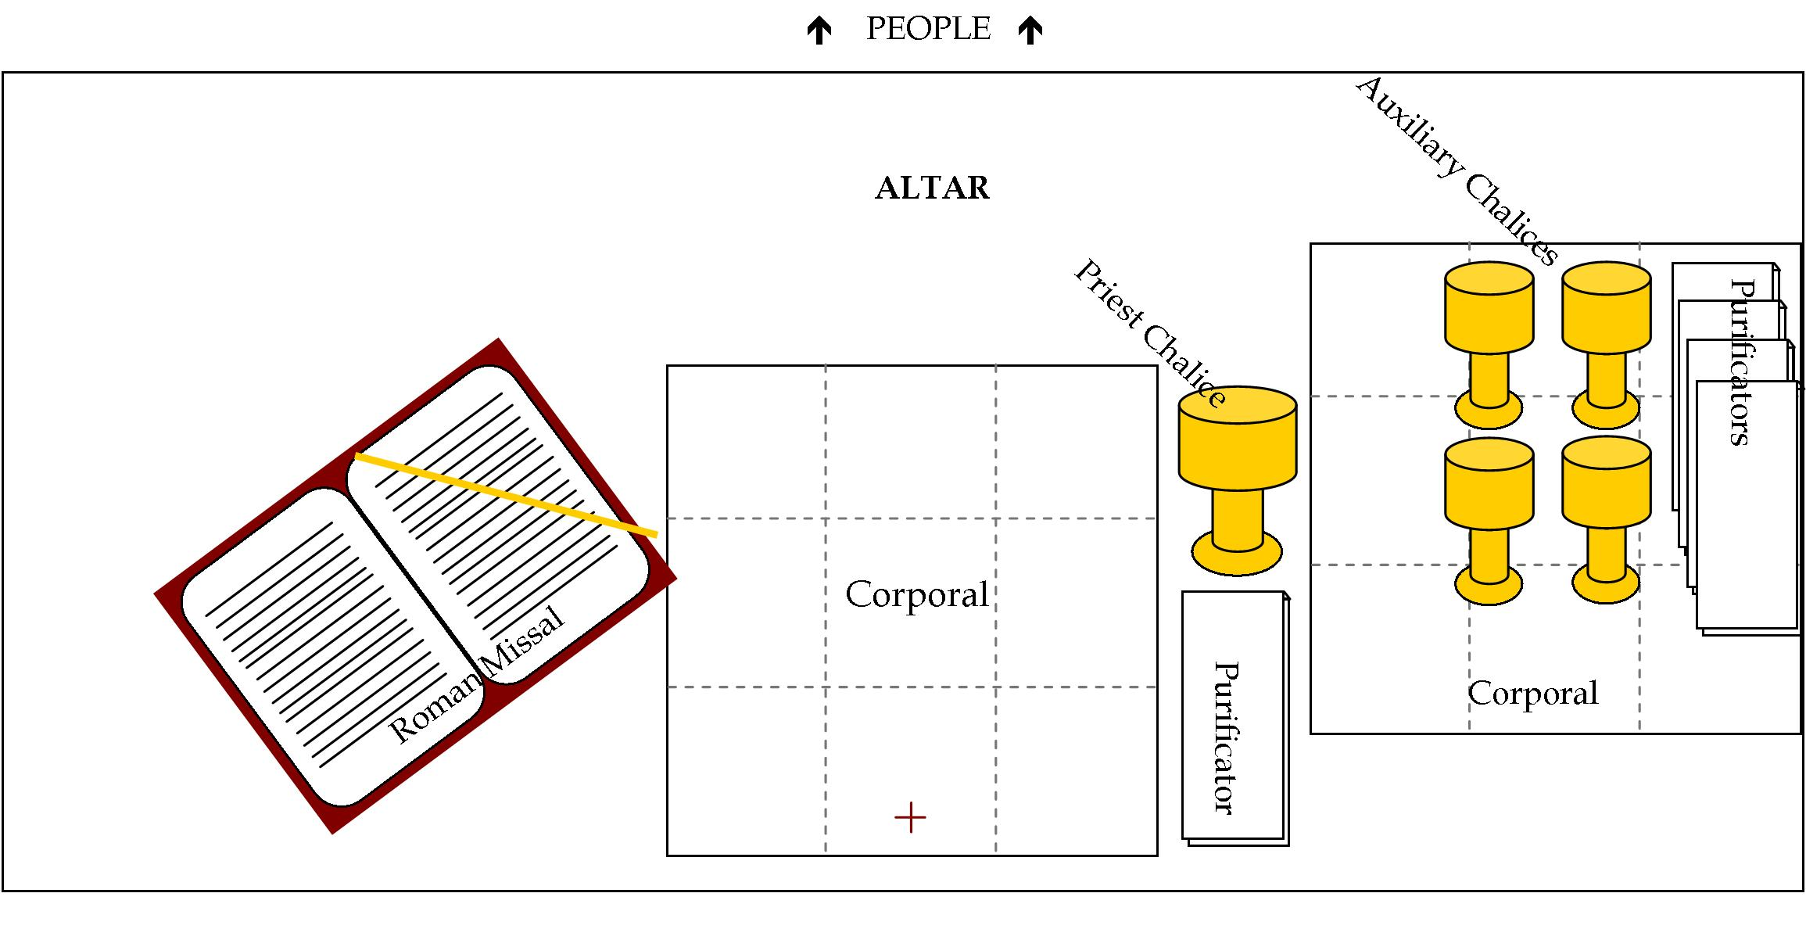
Illustration 1 (for Masses when both species are offered):

Illustration 2 (for Masses when only the Host is offered):
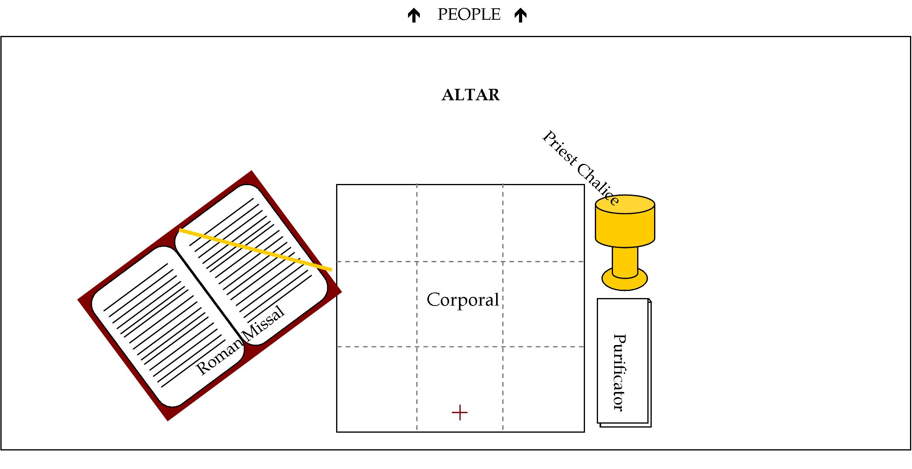
- After setting the altar, the servers return to their seats. When the gifts are ready to be brought forward, the servers stand and walk over to the center aisle to accept them with the presider. One server will receive the collection basket which is then placed directly in front of the altar or a little off to the side . The other server will receive the pitcher of wine or the paten/ciborium of hosts. Walk up and around the right side of the altar and place the pitcher of wine or paten/ciborium of bread on the right side of the altar next to the cup [DO NOT PLACE THE WINE OR HOSTS ON THE CENTER CORPORAL]. After placing the collection basket or the pitcher of wine, both servers move towards the credence table.
- Servers bring up the water, towel and lavabo bowl. One server should have the water and bowl, the other should have the towel. The pitcher of water is taken first to be used for the chalice, and then is returned to the server. Be sure to have the handle of the cruet or pitcher facing the priest or deacon so that he can grasp it easily. After the priest bows, the servers wash the hands of the priest, with one server pouring the water over his hands into the bowl, and the other handing the priest the towel to dry his hands. Both servers should bow their heads slightly to the priest and then return the vessels to the credence table.
- Servers will kneel along with the rest of the assembly during the Eucharistic Prayer. If bells are rung during the Eucharistic Prayer at the words of Instituion (Consecration), the altar server assigned to this task should position himself/herself as close to the bells as possible. Be careful not to move, lift or handle the bells too early since they will ring with any slight movement. The bells should be rung when the priest shows the consecrated host to the people at the conclusion of the words, “Take this, all of you, and eat of it, for this is my Body, which will be given up for you.” and when he shows the chalice to the people after the words, “Do this in memory of me.”
- Altar servers may need to assist the priest in bringing additional ciboria from the credence table to the altar during the Lamb of God.
- Servers receive communion as normal. Some parishes may ask altar servers to use the “chin” patens for those receiving communion. This requires the altar server to follow the consecrated host with the “chin” paten and placing it under the hands or under the chin of the person receiving communion.
- Following Communion, altar servers may be expected to bring the cruet/pitcher of water to the priest or deacon at the altar to purify the sacred vessels. After Communion, nothing should be left on the altar, so the priest or deacons may ask the altar servers to carry the sacred vessels, linens, and Roman Missal back to the credence table.
- Once the closing song has begun and the priest moves to the altar, servers should get the processional candles. Once the priest is ready, walk slowly (about one step a second) down the center aisle just a step behind (or side-by-side) the cross bearer. Upon reaching the back of the church, you may return to the sacristy to disrobe and to carry out any post-Mass responsibilities.

After Mass:
Your parish may have specific duties required of the altar server immediately after Mass. In addition to taking off your alb or cassock and hanging them up neatly, other responsibilities may include: extinguishing altar candles, bringing the sacred vessels and linens into the sacristy and emptying the lavabo bowl.

Practicum
Have the new servers practice in the two roles of cross/book bearer and candle bearer/server at the altar. Remind them about proper postures and keeping hands folded throughout the practicum.

Other Aspects of the Ministry

Sprinkling Rite
On occasion, a Sprinkling Rite may be celebrated in the Introductory Rites instead of the Penitential Rite. This immediately follows the Sign of the Cross and Greeting at the beginning of Mass, so as soon as the cross bearer places the procession cross in the stand, he or she should get the Roman Missal from its usual place. The candle bearers should place their processional candles down, and one server should go over to the vessel of water or take the vessel of water and stand next to the priest. At the conclusion of the song, the server brings the Roman Missal to the priest for the blessing. Following the blessing, the priest will dip the aspergillum into the holy water and begin sprinkling the faithful. The altar server accompanies the priest down the aisle allowing him to dip the aspergillum into the vessel. The book bearer should have the Roman Missal ready when the priest returns so that he can conclude the rite with a simple prayer.

Incense:
Your parish may use incense at a special Mass or during a specific Mass on the weekend. The use of incense is an ancient custom used in worship, and is richly symbolic in the Catholic tradition. The sacrifice of incense grains are burned and the fragrant smoke that ascends symbolizes our prayers and praise ascending to God in heaven. It is also used to honor people and things that are holy. The use of incense at Mass requires a specially trained altar server called a thurifer.
The charcoal inside the thurible (or censer) should be lit about 10 minutes prior to the start of Mass so that it is hot enough to burn incense and create enough smoke. Be sure to light all edges of the charcoal so that it burns all around. Also check that the boat is filled with enough incense. If incense is used throughout Mass, it is the responsibility of the thurifer (or MC) to make sure the charcoals are hot. This requires the additional charcoal being added to the thurible periodically during Mass.
Practice using the thurible well before Mass. You should be able to lift, open and close the thurible with ease. Be careful when handling the thurible since it will be very hot. Never touch the metal part of the thurible or the part of the chain closest to the lid, since these will be the hottest parts. You should be able to grasp the plastic or wooden knob at the top of the thurible.
Every time the priest prepares the incense, the thurifer should first hand the boat to the priest, deacon or MC. Next, the thurifer should open the lid to the thurible by grasping the knob or pulling the chain. The thurifer should then lift the thurible up to a level high enough so that the priest can easily add grains of incense to the charcoal. This can be done by either turning the thurible lid to pull the thurible up or by lifting up the top of the chain.
Incense is typically used at four points within the Mass:
- Entrance Procession—at Masses where incense is used, the thurifer leads the entrance procession. Prior to the singing of the Entrance Hymn, the priest puts incense in the thurible so that enough smoke is visible while moving down the aisle. The thurifer should swing the incense forward and backward while moving in procession. When the thurifer arrives at the foot of the sanctuary, he or she should bow his or her head to the altar and then move into the sanctuary to the place where the priest will prepare the incense for the incensation of the altar.
- Gospel Book Procession—after some silence following the Second Reading, the thurifer kneels down to the priest at the chair to prepare the incense. The thurifer will move to a designated spot until the priest or deacon goes to the altar and lifts up the Book of the Gospels. The thurifer leads the Gospel Book Procession around the altar to the ambo. Once arriving at the ambo, the thurifer moves a step or two behind the ambo to allow the deacon or priest through. Upon announcing the gospel author, the priest or deacon will reach for the thurible to honor to Book of the Gospels. Once the thurible is returned, the thurifer remains standing behind and slightly to either side of the ambo for the entire reading of the gospel. Once the gospel reading is completed (“Praise to you, Lord Jesus Christ), the thurifer returns the thurible to the sacristy.
- Preparation of the Gifts--if used at the Preparation of the Gifts, incense is used prior to the priest washing his hands (think fire before water). The priest prepares the incense as before and incenses the gifts of bread and wine as well as the altar and crucifix. While the priest is incensing, the thurifer should set the boat down on the credence table since you are going to need both hands to incense the priest and people. When the priest returns the incense, the thurifer should make a profound bow to the priest, and, while doing so, reach down the chain and grasp it and then proceed to incense or “wave” the thurible at the priest (usually 3 sets of two waves). After incensing the priest, the thurifer bows and then incenses, in the same manner, any other concelebrants (priests) present. Following the incensation of the priests, the thurifer moves down the center aisle while gesturing for the assembly to stand. After they have stood, the thurifer bows to them and incenses them in the same manner, but directs one set of doubles to diagonally left, then center and then diagonally right. The thurifer bows again to the assembly and then returns the thurible to the sacristy. Don’t forget to take the boat from the credence table on your way back.
- Recessional--incense may accompany the procession at the end of Mass. Instead of the priest preparing the incense, the thurifer should put some grains of incense into the thurible prior to leaving the sacristy. The thurifer again leads the procession down the aisle.

Serving at Funerals:
Most funerals in Catholic churches take place within the context of Mass. While most of the procedures for serving at a funeral are the same as serving at Sunday Mass, there are a few differences:
- Introductory Rite—the usual Introductory Rites from Sunday Mass are omitted and instead, the altar servers and the priest move toward the doors of the church for the rite of reception of the body. While the number of altar servers present determines the use of crucifix and candles, the bucket of holy water and the aspergillum (sprinkler) is necessary for this first part. Following the sprinkling with holy water and the placing of the pall, the servers and the priest lead the procession to the sanctuary. At the conclusion of the Entrance Hymn, the priest offers the Opening Prayer.
- Gospel Book Procession—parishes may choose to omit the Gospel Book Procession at funeral Masses.
- Preparation of the Gifts—some priests may choose to use incense during the Preparation of the Gifts at funeral Masses. Incense is used prior to the priest washing his hands (think fire before water). In preparing the incense the thurifer should first hand the boat to the priest or deacon. Next, the thurifer should open the lid to the thurible by grasping the knob or pulling the chain. The thurifer should then lift the thurible up to a level high enough so that the priest can easily add grains of incense to the charcoal. This can be done by either turning the thurible lid to pull the thurible up or by lifting up the top of the chain. While the priest is incensing, the thurifer should set the boat down on the credence table since you are going to need both hands to incense the priest. If incensing the him, the thurifer should make a profound bow to the priest, and, while doing so, reach down the chain and grasp it and then proceed to incense or “wave” the thurible at the priest (usually 3 sets of two waves). The priests hands are washed by the other servers immediately after the incense is used.
- Final Commendation—following the Prayer after Communion, the altar servers take the cross, processional candles, thurible and boat and move down towards the casket. The cross and two candles should line up on the far side of the casket and face the altar. The thurifer should stand on the other side of the casket, by the priest and face the people. The priest will invite the people to pray for the deceased, and then prepare the incense as mentioned above. The priest will incense the deceased while the Song of Farewell is sung. The priest will then return the incense to the thurifer, who should then join the other servers, standing behind the cross bearer. As the music for the procession begins, the priest and deacon will join the altar servers on the other side of the casket. Wait until the priest joins you and turns to process down the aisle—the priest may just join you first, and then wait for the funeral directors to turn the casket around, so you don’t want to start moving down the aisle too quickly!

